*1.DETERMINISTIC FINITE AUTOMATA*

*INPUT:*

*#include<stdio.h>*

*#include<string.h>*

*#define max 20*

*int main()*

*{*

*int trans_table[4][2]={{1,3},{1,2},{1,2},{3,3}};*

*int final_state=2,i;*

*int present_state=0;*

*int next_state=0;*

*int invalid=0;*

*char input_string[max];*

*printf("enter a string: ");*

*scanf("%s",input_string);*

*int l=strlen(input_string);*

*for(i=0;i<l;i++)*

*{*

*if(input_string[i]=='a')*

*next_state=trans_table[present_state][0];*

*else if(input_string[i]=='b')*

*next_state=trans_table[present_state][1];*

*else*

*invalid=l;*

*present_state=next_state;*

*}*

*if(invalid==l)*

*{*

*printf("invalid input");*

*}*

*else if(present_state==final_state)*

*printf("accept\n");*

*else*

*printf("dont accept\n");*

*}*

*OUTPUT:*

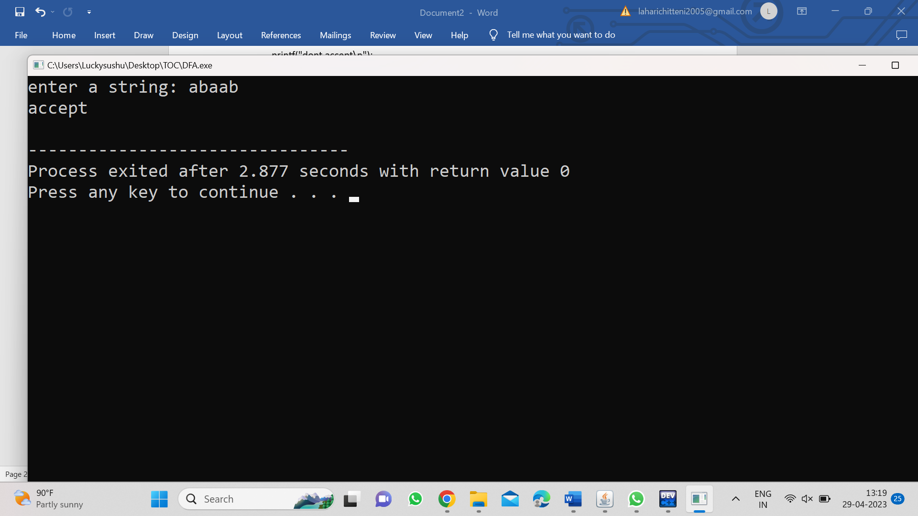

*2.NON-DETERMINISTIC FINITE AUTOMATA:*

*INPUT:*

*#include<stdio.h>*

*#include<string.h>*

*int main()*

*{*

*int i,j,k,l,m,next_state[20],n,mat[10][10][10],flag,p,exit;*

*int num_states,final_state[5],num_symbols,num_final;*

*int present_state[20],prev_trans,new_trans;*

*char ch,input[20];*

*int symbol[5],inp,inp1;*

*printf("how many states in the nfa: ");*

*scanf("%d",&num_states);*

*printf("how many symbols in the input alphabet: ");*

*scanf("%d",&num_symbols);*

*for(i=0;i<num_symbols;i++)*

*{*

*printf("enter the input symbol %d: ",i+1);*

*scanf("%d",&symbol[i]);*

*}*

*printf("how many final states: ");*

*scanf("%d",&num_final);*

*for(i=0;i<num_final;i++)*

*{*

*printf("enter the final state %d: ",i+1);*

*scanf("%d",&final_state[i]);*

*}*

*for(i=0;i<10;i++)*

*{*

*for(j=0;j<10;j++)*

*{*

*for(k=0;k<10;k++)*

*{*

*mat[i][j][k]=-1;*

*}*

*}*

*}*

*for(i=0;i<num_states;i++)*

*{*

*for(j=0;j<num_symbols;j++)*

*{*

*printf("how many transitions from state %d for the input %d: ",i,symbol[j]);*

*scanf("%d",&n);*

*for(k=0;k<n;k++)*

*{*

*printf("enter the transition %d from state %d for the input %d: ",k+1,i,symbol[j]);*

*scanf("%d",&mat[i][j][k]);*

*}*

*}*

*}*

*printf("the transitions are stored as below\n");*

*for(i=0;i<10;i++)*

*{*

*for(j=0;j<10;j++)*

*{*

*for(k=0;k<10;k++)*

*{*

*if(mat[i][j][k]!=-1)*

*printf("mat[%d][%d][%d]=%d\n",i,j,k,mat[i][j][k]);*

*}*

*}*

*}*

*while(1)*

*{*

*printf("enter the input string: ");*

*scanf("%s",input);*

*present_state[0]=0;*

*prev_trans=1;*

*l=strlen(input);*

*for(i=0;i<l;i++)*

*{*

*if(input[i]=='0')*

*inp1=0;*

*else if(input[i]=='1')*

*inp=1;*

*else*

*{*

*printf("invalid input\n");*

*exit;*

*}*

*for(m=0;m<num_symbols;m++)*

*{*

*if(inp1==symbol[m])*

*{*

*inp=m;*

*break;*

*}*

*}*

*new_trans=0;*

*for(j=0;j<prev_trans;j++)*

*{*

*k=0;*

*p=present_state[j];*

*while(mat[p][inp][k]!=-1)*

*{*

*next_state[new_trans++]=mat[p][inp][k];*

*k++;*

*}*

*}*

*for(j=0;j<new_trans;j++)*

*{*

*present_state[j]=next_state[j];*

*}*

*prev_trans=new_trans;*

*}*

*flag=0;*

*for(i=0;i<prev_trans;i++)*

*{*

*for(j=0;j<num_final;j++)*

*{*

*if(present_state[i]==final_state[j])*

*{*

*flag=1;*

*break;*

*}*

*}*

*}*

*if(flag==1)*

*printf("accepted\n");*

*else*

*printf("not accepted\n");*

*printf("try with another input\n");*

*}*

*}*

*OUTPUT:*

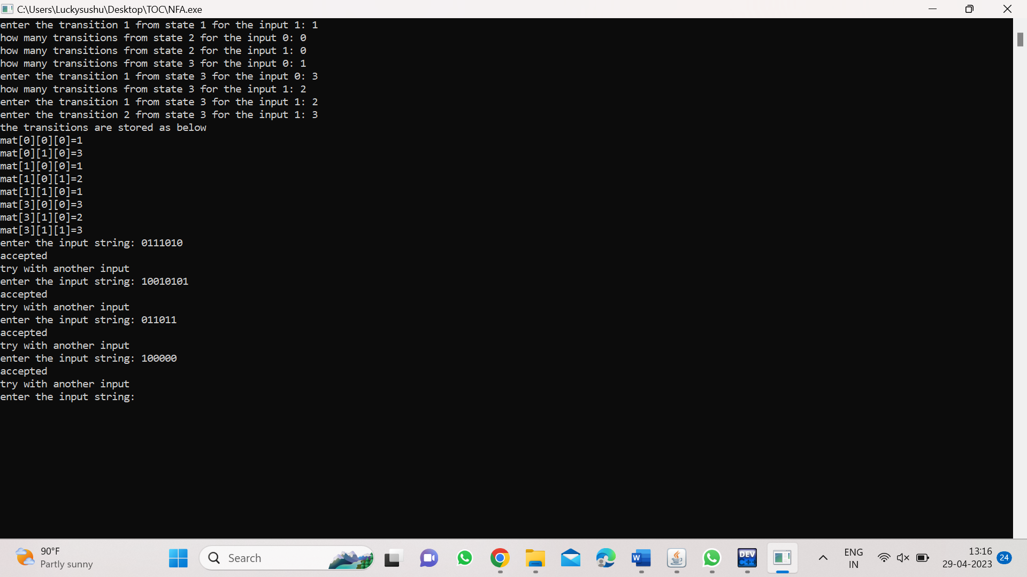

*3.EPSILON CLOSURE FOR NFA*

*INPUT:*

*#include<stdio.h>*

*#include<string.h>*

*int trans_table[10][5][3];*

*char symbol[5],a;*

*int e_closure[10][10],ptr,state;*

*void find_e_closure(int x);*

*int main()*

*{*

*int i,j,k,n,num_states,num_symbols;*

*for(i=0;i<10;i++)*

*{*

*for(j=0;j<5;j++)*

*{*

*for(k=0;k<3;k++)*

*{*

*trans_table[i][j][k]=-1;*

*}*

*}*

*}*

*printf("How many states in the NFA with e-moves:");*

*scanf("%d",&num_states);*

*printf("How many symbols in the input alphabet including e:");*

*scanf("%d",&num_symbols);*

*printf("Enter the symbols without space.Give 'e' first:");*

*scanf("%s",symbol);*

*for(i=0;i<num_states;i++)*

*{*

*for(j=0;j<num_symbols;j++)*

*{*

*printf("How many transitions from state %d for the input %c:",i,symbol[j]);*

*scanf("%d",&n);*

*for(k=0;k<n;k++)*

*{*

*printf("Enter the transitions %d from state %d for the input %c:",i,symbol[j]);*

*scanf("%d",&trans_table[i][j][k]);*

*}*

*}*

*}*

*for(i=0;i<10;i++)*

*{*

*for(j=0;j<10;j++)*

*{*

*e_closure[i][j]=-1;*

*}*

*}*

*for(i=0;i<num_states;i++)*

*e_closure[i][0]=i;*

*for(i=0;i<num_states;i++)*

*{*

*if(trans_table[i][0][0]==-1)*

*continue;*

*else*

*{*

*state=i;*

*ptr=1;*

*find_e_closure(i);*

*}*

*}*

*for(i=0;i<num_states;i++)*

*{*

*printf("e-closure(%d)={",i);*

*for(j=0;j<num_states;j++)*

*{*

*if(e_closure[i][j]!=-1)*

*{*

*printf("%d,",e_closure[i][j]);*

*}*

*}*

*printf("}\n");*

*}*

*}*

*void find_e_closure(int x)*

*{*

*int i,j,y[10],num_trans;*

*i=0;*

*while(trans_table[x][0][i]!=-1)*

*{*

*y[i]=trans_table[x][0][i];*

*i=i+1;*

*}*

*num_trans=i;*

*for(j=0;j<num_trans;j++)*

*{*

*e_closure[state][ptr]=y[j];*

*ptr++;*

*find_e_closure(y[j]);*

*}*

*}*

*OUTPUT:*

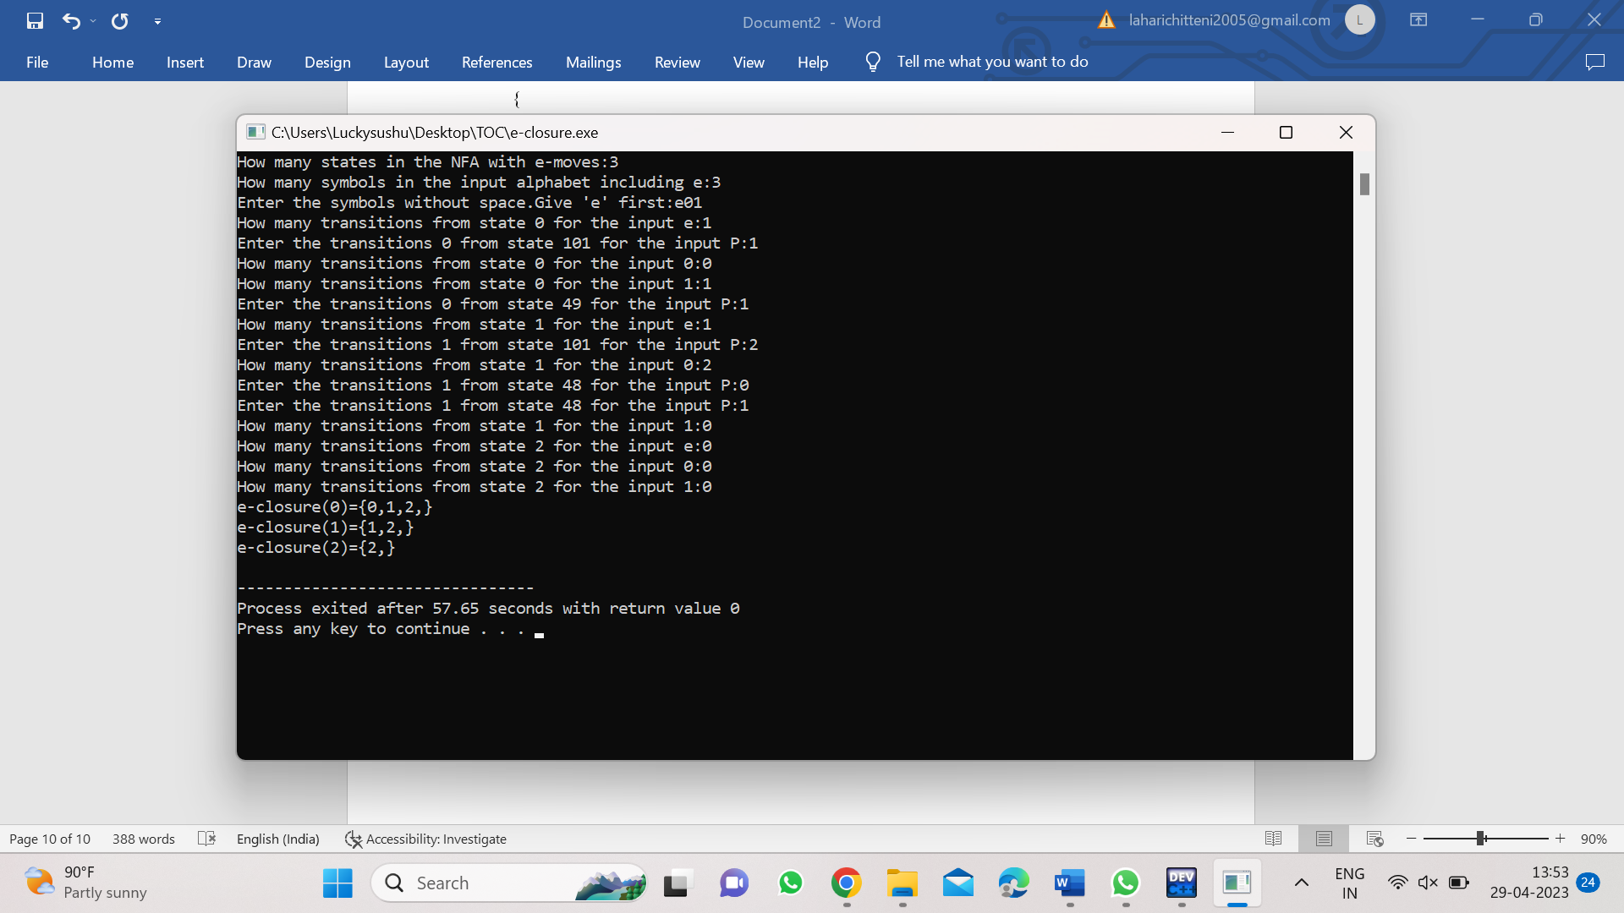

*4.CHECKING STRING BELONGS TO THE GRAMMAR*

*INPUT:*

*#include<stdio.h>*

*#include<string.h>*

*int main()*

*{*

*char s[100];*

*int i,flag;*

*int l;*

*printf("enter the string to check:");*

*scanf("%s",s);*

*l=strlen(s);*

*flag=1;*

*for(i=0;i<l;i++)*

*{*

*if(s[i]!='0' && s[i]!='1')*

*{*

*flag=0;*

*}*

*}*

*if(flag!=1)*

*printf("string is not valid\n");*

*if(flag==1)*

*{*

*if(s[0]=='0'&&s[l-1]=='1')*

*printf("string is accepted\n");*

*else*

*printf("string is not accepted");*

*}*

*}*

*OUTPUT:*

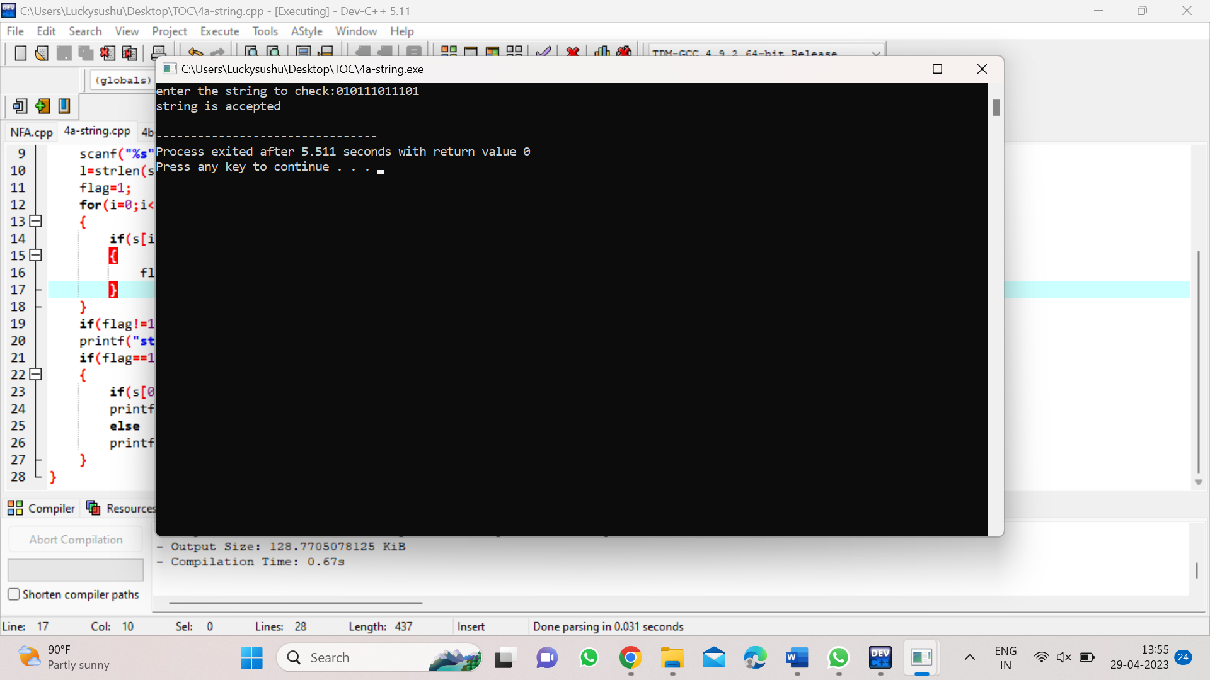

*5.CHECKING WHETHER STRING BELONGS TO THE GRAMMAR*

*INPUT:*

*#include<stdio.h>*

*#include<string.h>*

*int main()*

*{*

*char s[100];*

*int i,flag,flag1,a,b;*

*int l;*

*printf("enter the string to check: ");*

*scanf("%s",s);*

*l=strlen(s);*

*flag=1;*

*for(i=0;i<l;i++)*

*{*

*if(s[i]!='0' && s[i]!='1')*

*{*

*flag=0;*

*}*

*}*

*if(flag!=1)*

*printf("string is not valid\n:");*

*if(flag==1)*

*{*

*flag1=1;*

*a=0;*

*b=l-1;*

*while(a!=(1/2))*

*{*

*if(s[a]!=s[b])*

*{*

*flag1=0;*

*}*

*a=a+1;*

*b=b-1;*

*}*

*if(flag1==1)*

*{*

*printf("the string is a palindrome\n");*

*printf("string is accepted\n");*

*}*

*else*

*{*

*printf("the string is not a palindrome\n");*

*printf("string is not accepted\n");*

*}*

*}*

*}*

*OUTPUT:*

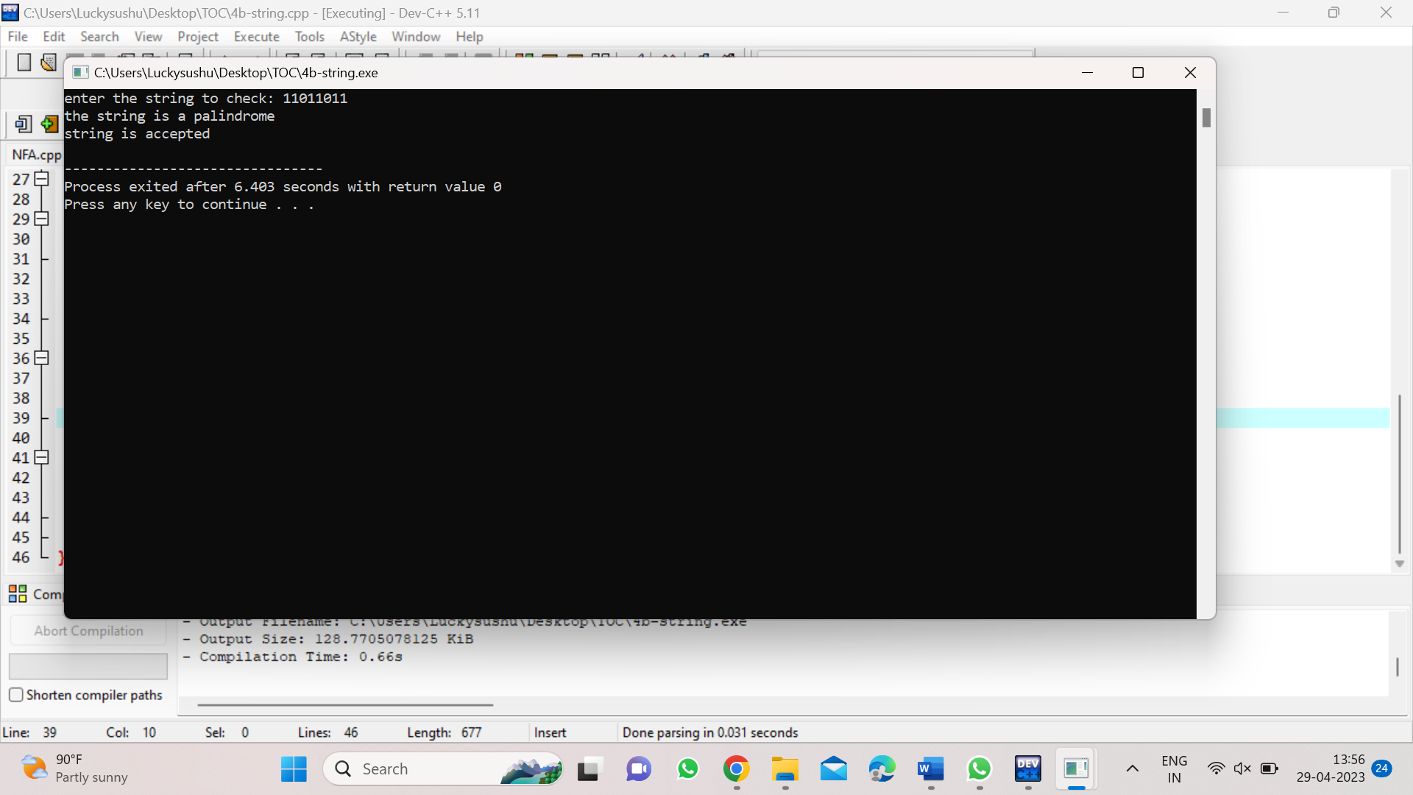

*6.CHECKING WHETHER STRING BELONGS TO THE GRAMMAR*

*INPUT:*

*#include<stdio.h>*

*#include<string.h>*

*int main()*

*{*

*char s[100];*

*int i,flag,flag1,a,b;*

*int l,count1,count2;*

*printf("enter a string to check: ");*

*scanf("%s",s);*

*l=strlen(s);*

*flag=1;*

*for(i=0;i<l;i++)*

*{*

*if(s[i]!='0' &&s[i]!='1')*

*{*

*flag=0;*

*}*

*}*

*if(flag!=1)*

*printf("string is not valid\n");*

*if(flag==1)*

*{*

*i=0;*

*count1=0;*

*while(s[i]=='0')*

*{*

*count1++;*

*i++;*

*}*

*while(s[i]=='1')*

*{*

*i++;*

*}*

*flag1=1;*

*count2=0;*

*while(i<l)*

*{*

*if(s[i]=='0')*

*{*

*count2++;*

*}*

*else*

*{*

*flag1=0;*

*}*

*i++;*

*}*

*if(flag1==1)*

*{*

*if(count1==count2)*

*{*

*printf("the string satisfies the condition 0^n1^m0^n\n");*

*printf("string accepted\n");*

*}*

*else*

*{*

*printf("the string does not satisfy the condition 0^n1^m0^n\n");*

*printf("string not accepted\n");*

*}*

*}*

*else*

*{*

*printf("the string does not satisfy the condition 0^n1^m0^n\n");*

*printf("string not accepted\n");*

*}*

*}*

*}*

*OUTPUT:*

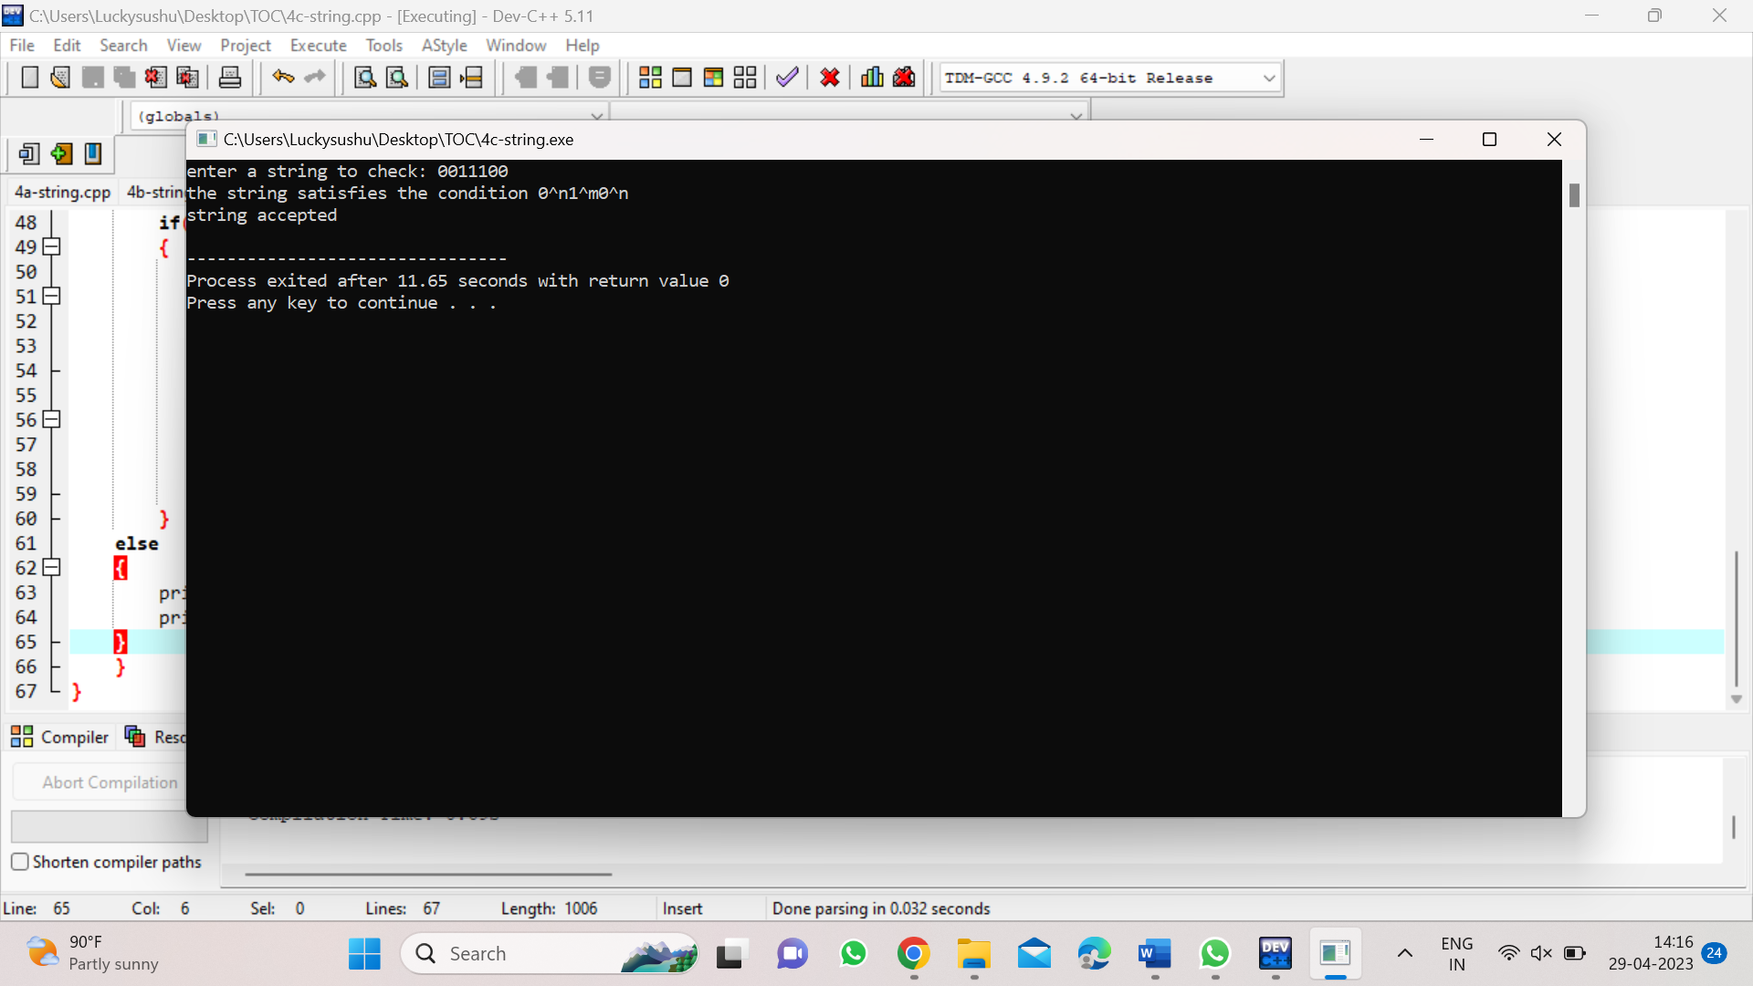

*7.CHECKING WHETHER STRING BELONGS TO THE GRAMMAR*

*INPUT:*

*#include<stdio.h>*

*#include<string.h>*

*int main()*

*{*

*char s[100];*

*int i,flag,flag1,flag2;*

*int l;*

*printf("enter a string to check: ");*

*scanf("%s",s);*

*l=strlen(s);*

*flag=1;*

*for(i=0;i<l;i++)*

*{*

*if(s[i]!='0' && s[i]!='1')*

*{*

*flag=0;*

*}*

*}*

*if(flag!=1)*

*printf("string is not valid\n");*

*if(flag==1)*

*{*

*if(l%2!=0)*

*{*

*printf("the string doesnot satisfy the condition 0^n1^n\n");*

*printf("string not accepted\n");*

*}*

*else*

*{*

*flag1=1;*

*for(i=0;i<(l/2);i++)*

*{*

*if(s[i]!='0')*

*{*

*flag1=0;*

*}*

*}*

*flag2=1;*

*for(i=l/2;i<l;i++)*

*{*

*if(s[i]!='1')*

*{*

*flag2=0;*

*}*

*}*

*if(flag1==1 && flag2==1)*

*{*

*printf("the string satisfies the condition 0^n1^n\n");*

*printf("string accepted\n");*

*}*

*else*

*{*

*printf("the string does not satisfies the condition 0^n1^n\n");*

*printf("string not accepted\n");*

*}*

*}*

*}*

*}*

*OUTPUT:*

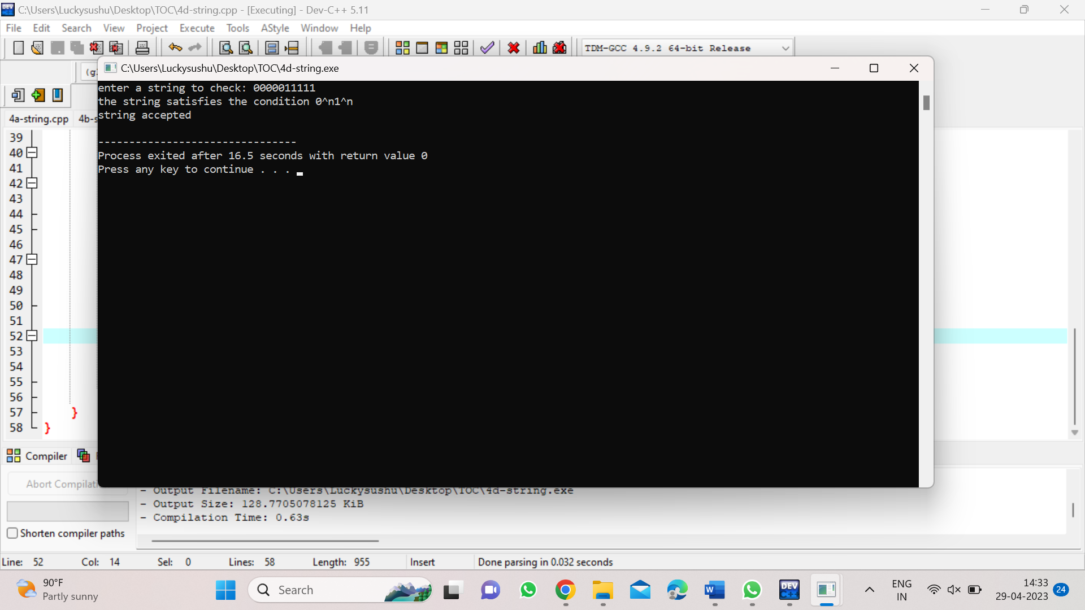

*8.CHECKING WHETHER STRING BELONGS TO THE GRAMMAR*

*INPUT:*

*#include<stdio.h>*

*#include<string.h>*

*int main()*

*{*

*char s[100];*

*int i,flag,flag1;*

*int l;*

*printf("enter the string to check: ");*

*scanf("%s",s);*

*l=strlen(s);*

*flag=1;*

*for(i=0;i<l;i++)*

*{*

*if(s[i]!='0' && s[i]!='1')*

*{*

*flag=0;*

*}*

*}*

*if(flag==1)*

*printf("string is valid\n");*

*else*

*printf("string is not valid\n");*

*if(flag==1)*

*{*

*flag1=0;*

*for(i=0;i<l-2;i++)*

*{*

*if(s[i]=='1')*

*{*

*if(s[i+1]=='0' && s[i+2]=='1')*

*{*

*flag1=1;*

*printf("substring 101 exists,string is accepted\n");*

*break;*

*}*

*}*

*}*

*if(flag1==0)*

*printf("substring 101 does not exist.string is not accepted\n");*

*}*

*}*

*OUTPUT:*

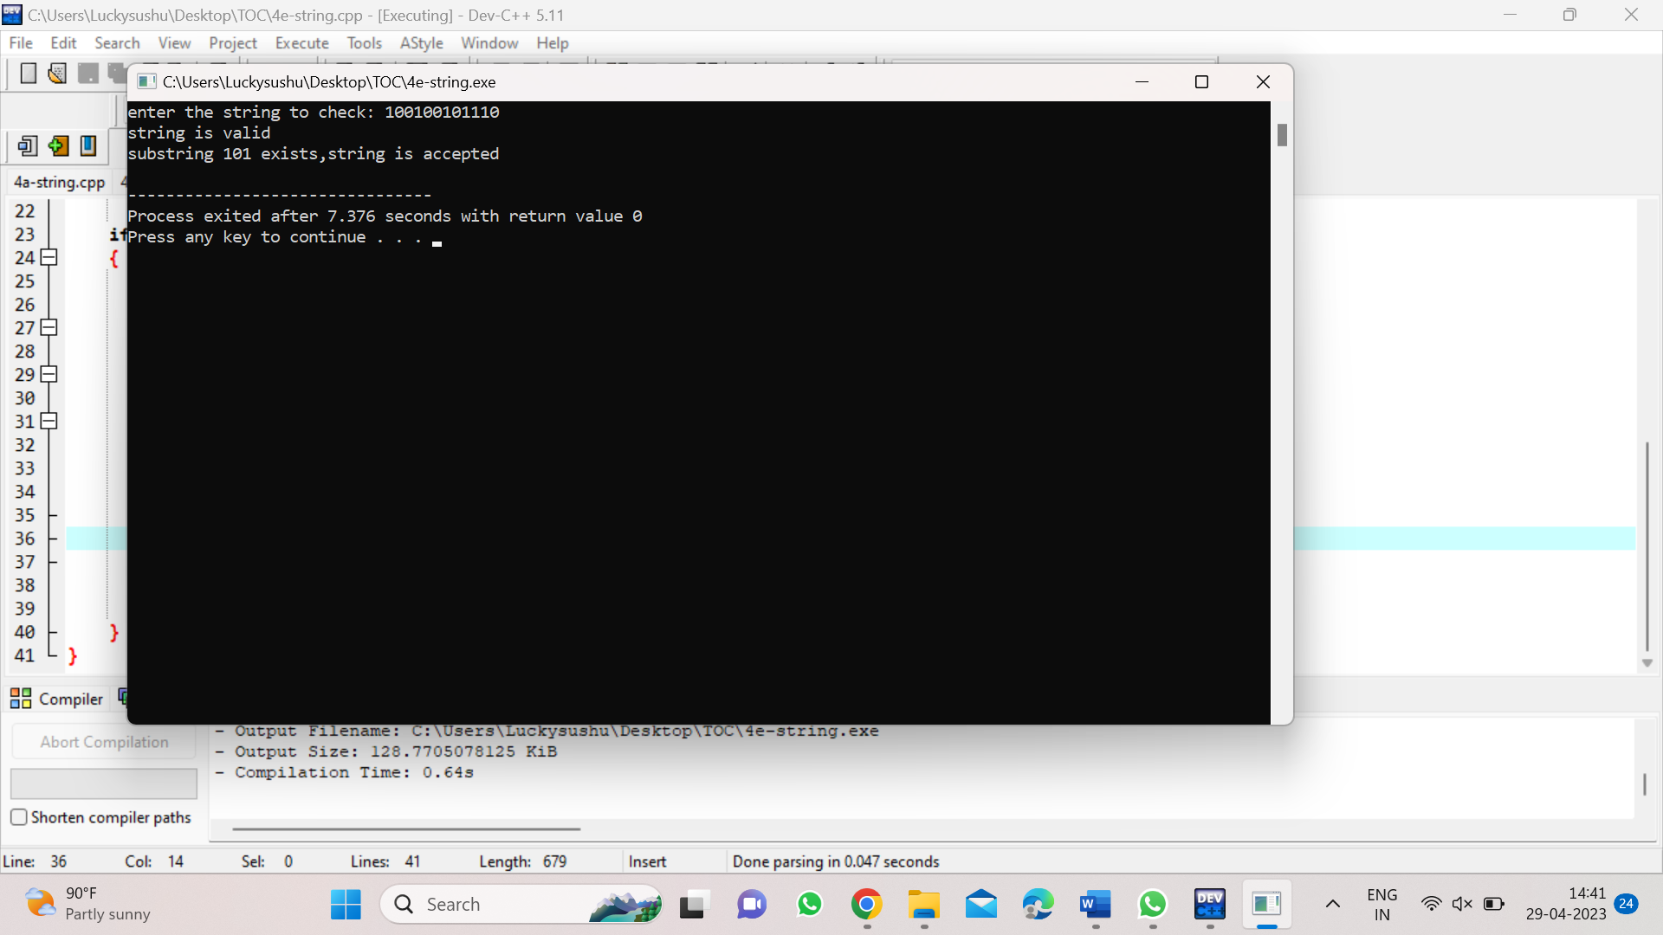

*9.SIMULATING PUSHDOWN AUTOMATA (0^n1^n):*

*INPUT:*

*#include<stdio.h>*

*#include<string.h>*

*char stack[20];*

*int top;*

*int push()*

*{*

*top=top+1;*

*stack[top]='0';*

*stack[top+1]='\0';*

*}*

*int pop()*

*{*

*if(top<1)*

*return(0);*

*else*

*{*

*stack[top]='\0';*

*top=top-1;*

*return(1);*

*}*

*}*

*int main()*

*{*

*int m,i,j,k,l,a,len;*

*char input[20],rem_input[20];*

*printf("Simulation of Pushdown Automata for 0n1n\n");*

*printf("Enter a string : ");*

*scanf("%s",input);*

*l=strlen(input);*

*j=0;stack[0]='Z';top=0;*

*printf("Stack\tInput\n");*

*printf("%s\t%s\n",stack,input);*

*while(1)*

*{*

*len=strlen(input);*

*while(len>0)*

*{*

*if(input[0]=='0')*

*{*

*push();*

*m=0;*

*for(k=1;k<len;k++)*

*{*

*rem_input[m]=input[k];*

*m=m+1;*

*}*

*rem_input[m]='\0';*

*strcpy(input,rem_input);*

*printf("%s\t%s\n",stack,input);*

*}*

*if(input[0]=='1')*

*{*

*a=pop();*

*if(a==0)*

*{*

*printf("String not accepted");*

*goto b;*

*}*

*else*

*{*

*m=0;*

*for(k=1;k<len;k++)*

*{*

*rem_input[m]=input[k];*

*m=m+1;*

*}*

*rem_input[m]='\0';*

*strcpy(input,rem_input);*

*printf("%s\t%s\n",stack,input);*

*}*

*}*

*break;*

*} j=j+1;*

*if(j==(l))*

*{ break;*

*}*

*}*

*if(top>=1)*

*{*

*printf("String not accepted");*

*} else*

*{*

*printf("String accepted");*

*} b: printf(".............");*

*}*

*OUTPUT:*

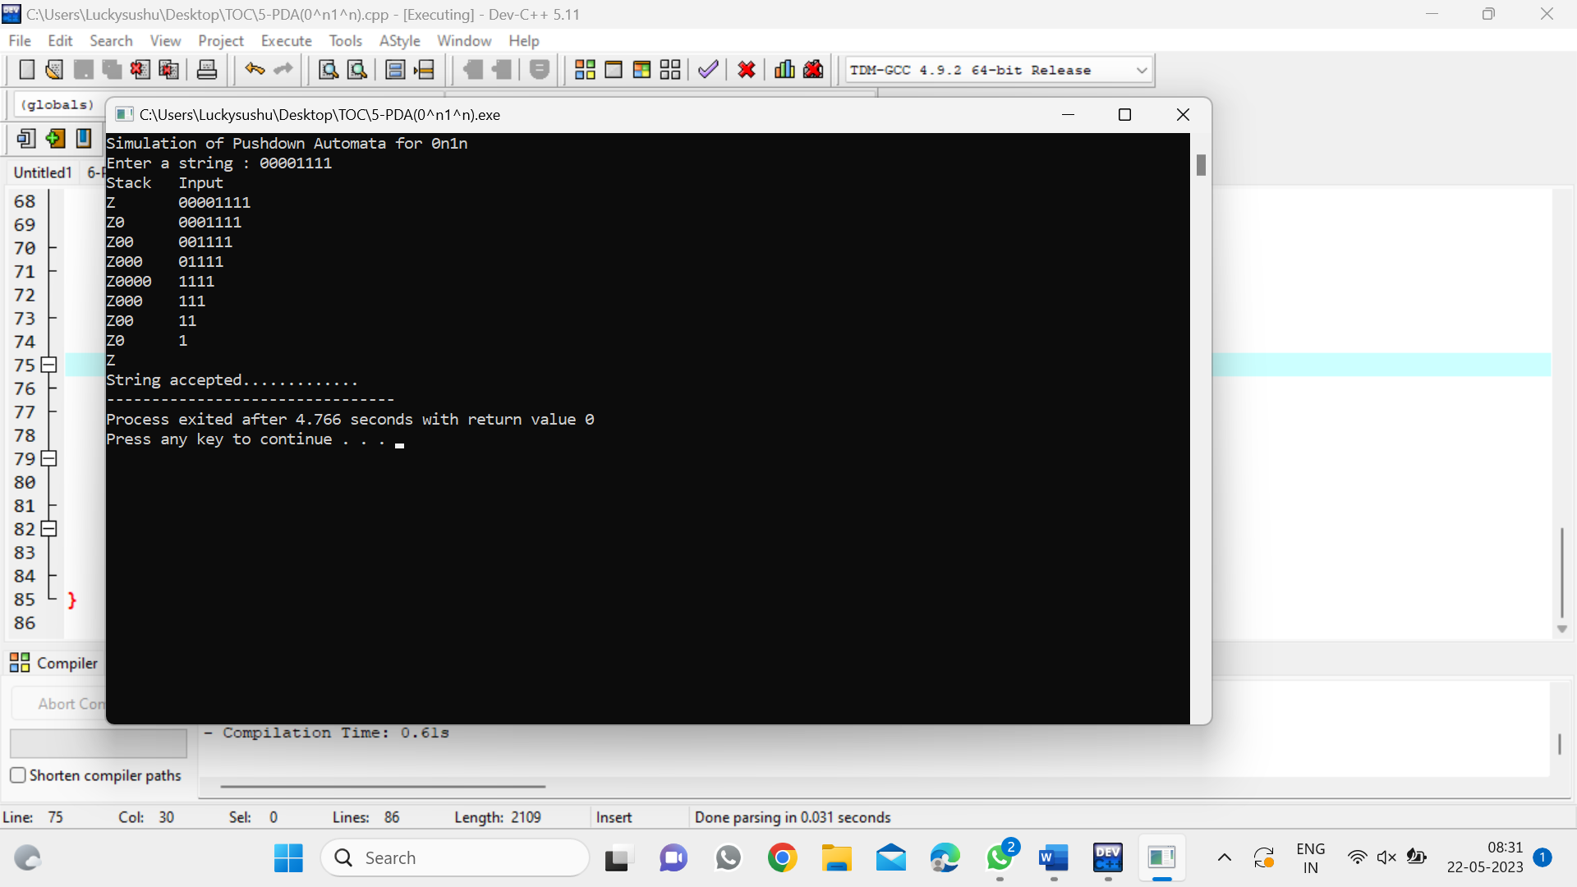

*10)SIMULATING PUSHDOWN AUTOMATA (0^N1^2N):*

*INPUT:*

*#include<stdio.h>*

*#include<string.h>*

*char stack[20];*

*int top,count=0;*

*int push()*

*{*

*top=top+1;*

*stack[top]='0';*

*stack[top+1]='\0';*

*}*

*int pop()*

*{*

*if(top<1)*

*return(0);*

*else*

*{*

*stack[top]='\0';*

*top=top-1;*

*return(1);*

*}*

*}*

*int main()*

*{*

*int m,i,j,k,l,a,len;*

*char input[20],rem_input[20];*

*printf("Simulation of PDA for n 0's followed by 2n 1's\n");*

*printf("Enter a string : ");*

*scanf("%s",input);*

*l=strlen(input);*

*j=0;*

*stack[0]='Z';*

*top=0;*

*printf("Stack\tInput\n");*

*printf("%s\t%s\n",stack,input);*

*while(1)*

*{*

*len=strlen(input);*

*while(len>0)*

*{*

*if(input[0]=='0')*

*{*

*push();*

*m=0;*

*for(k=1;k<len;k++)*

*{*

*rem_input[m]=input[k];*

*m=m+1;*

*}*

*rem_input[m]='\0';*

*strcpy(input,rem_input);*

*printf("%s\t%s\n",stack,input);*

*}*

*if(input[0]=='1')*

*{*

*count++;*

*if(count%2==0)*

*{*

*a=pop();*

*if(a==0)*

*{*

*printf("String not accepted");*

*goto b;*

*}*

*else*

*{*

*m=0;*

*for(k=1;k<len;k++)*

*{*

*rem_input[m]=input[k];*

*m=m+1;*

*}*

*}*

*rem_input[m]='\0';*

*strcpy(input,rem_input);*

*printf("%s\t%s\n",stack,input);*

*} else {*

*m=0;*

*for(k=1;k<len;k++)*

*{*

*rem_input[m]=input[k];*

*m=m+1;*

*}*

*rem_input[m]='\0';*

*strcpy(input,rem_input);*

*printf("%s\t%s\n",stack,input);*

*}*

*}*

*break;*

*}*

*j=j+1;*

*if(j==l)*

*{ break;*

*}*

*}*

*if(top>=1)*

*{*

*printf("String not accepted");*

*} else*

*{*

*printf("String accepted");*

*} b:*

*printf(".............");*

*}*

*OUTPUT:*

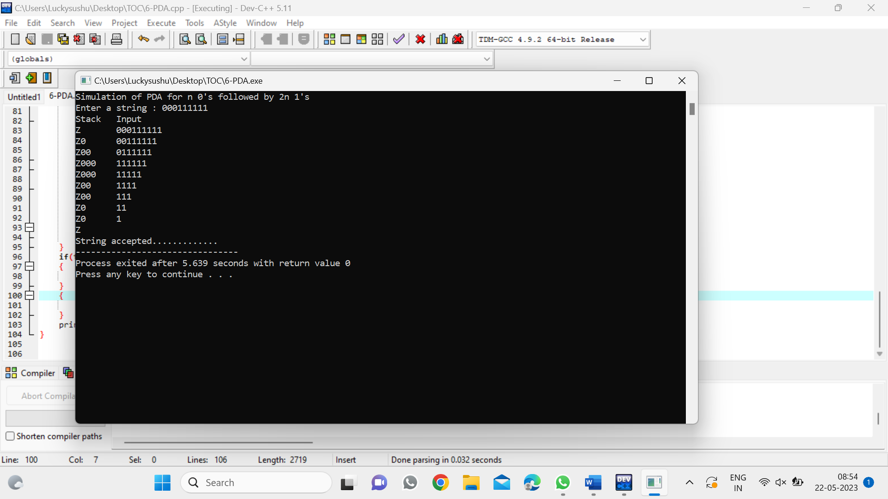

*11)SIMULATING TURING MACHINE(ON1N2N):*

*INPUT:*

*#include<stdio.h>*

*#include<string.h>*

*int main()*

*{*

*int i,j,le,flag,flag1,flag2;*

*char str[20];*

*printf("Program to show how a turing machine will process 0n1n2n\n");*

*printf("Enter a string : ");*

*scanf("%s",str);*

*le=strlen(str);*

*j=0; while(1)*

*{*

*flag=0;flag1=0;*

*flag2=0;i=0;*

*while(i<le)*

*{*

*if((str[i]=='0')&&(flag==0))*

*{*

*str[i] = 'A';*

*printf("%s\n",str);*

*flag=1;*

*i=i+1;*

*}*

*else if((str[i]=='0')&&(flag==1))*

*{*

*i=i+1;*

*}*

*else if(str[i]=='A')*

*{*

*i=i+1;*

*}*

*else if((str[i]=='1')&&(flag1==0))*

*{*

*str[i] = 'B';*

*printf("%s\n",str);*

*flag1=1;*

*i=i+1;*

*}*

*else if((str[i]=='1')&&(flag1==1))*

*{*

*i=i+1;*

*}*

*else if(str[i]=='B')*

*{*

*i=i+1;*

*}*

*else if((str[i]=='2')&&(flag2==0))*

*{*

*str[i] ='C';*

*printf("%s\n",str);*

*flag2=1;*

*i=i+1;*

*}*

*else if((str[i]=='2')&&(flag2==1))*

*{*

*i=i+1;*

*}*

*else if(str[i]=='C')*

*{*

*i=i+1;*

*}*

*}*

*j=j+1;*

*if(j==le)*

*{*

*break;*

*}*

*}*

*}*

*OUTPUT:*

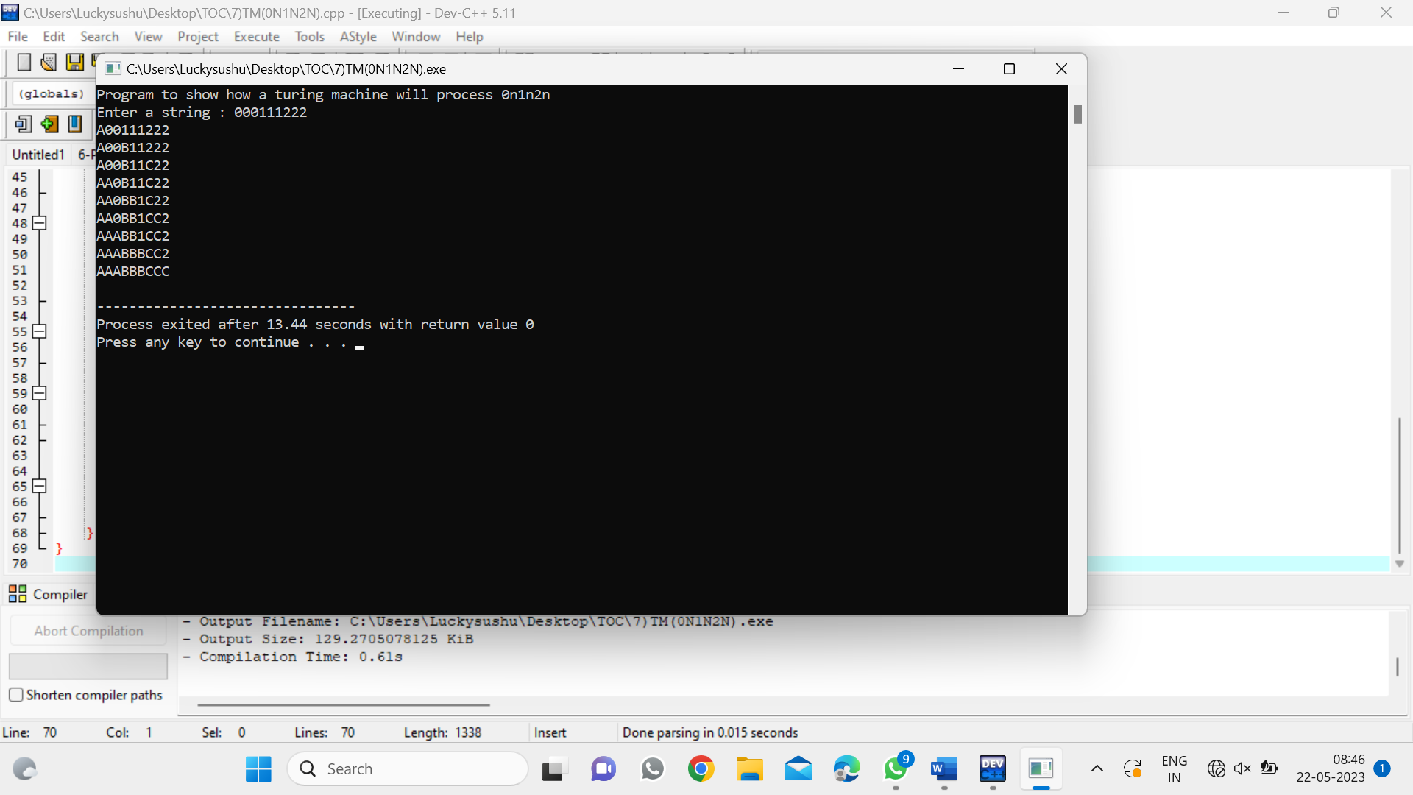

*SIMULATION PROGRAMS*

*Program 12*

*DFA to accept a,ac,bca:*

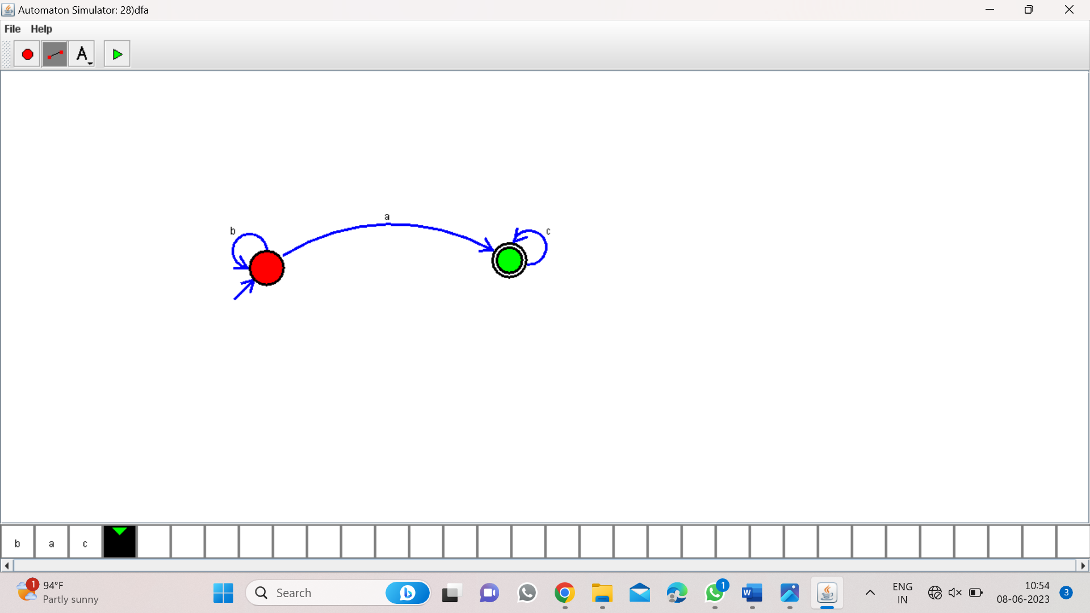

*Program 13:*

*PDA for a^nb^n:*

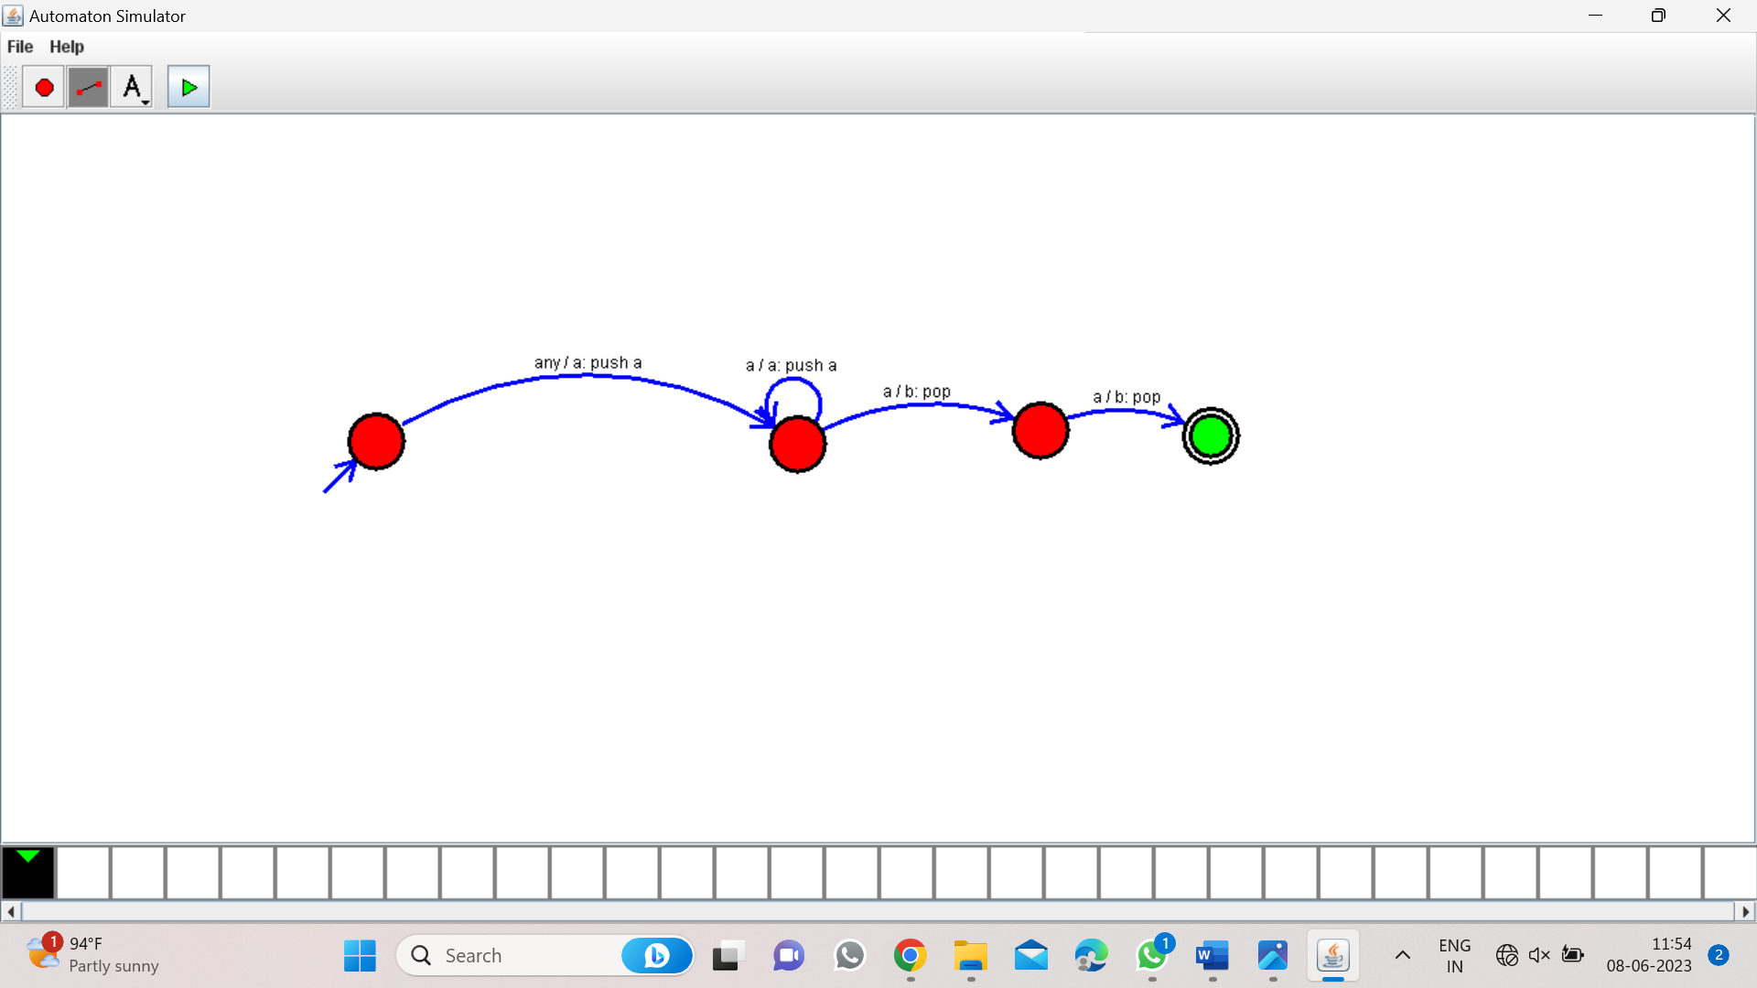

*PROGRAM 15:*

*TM For a^nb^n:*

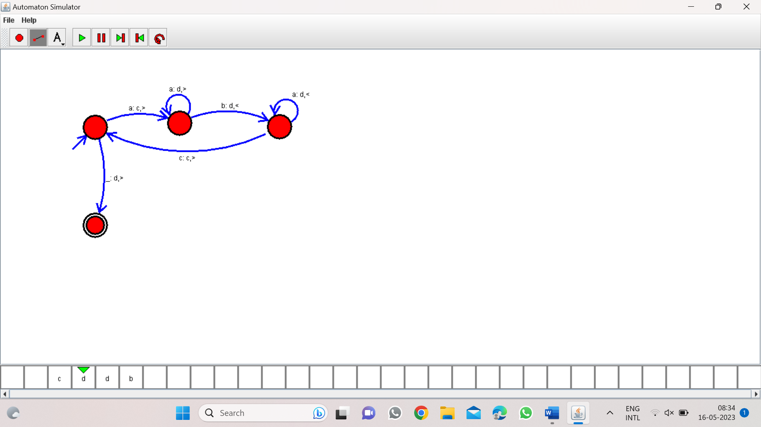

*PROGRAM16:*

*TM for a^nb^2n:*

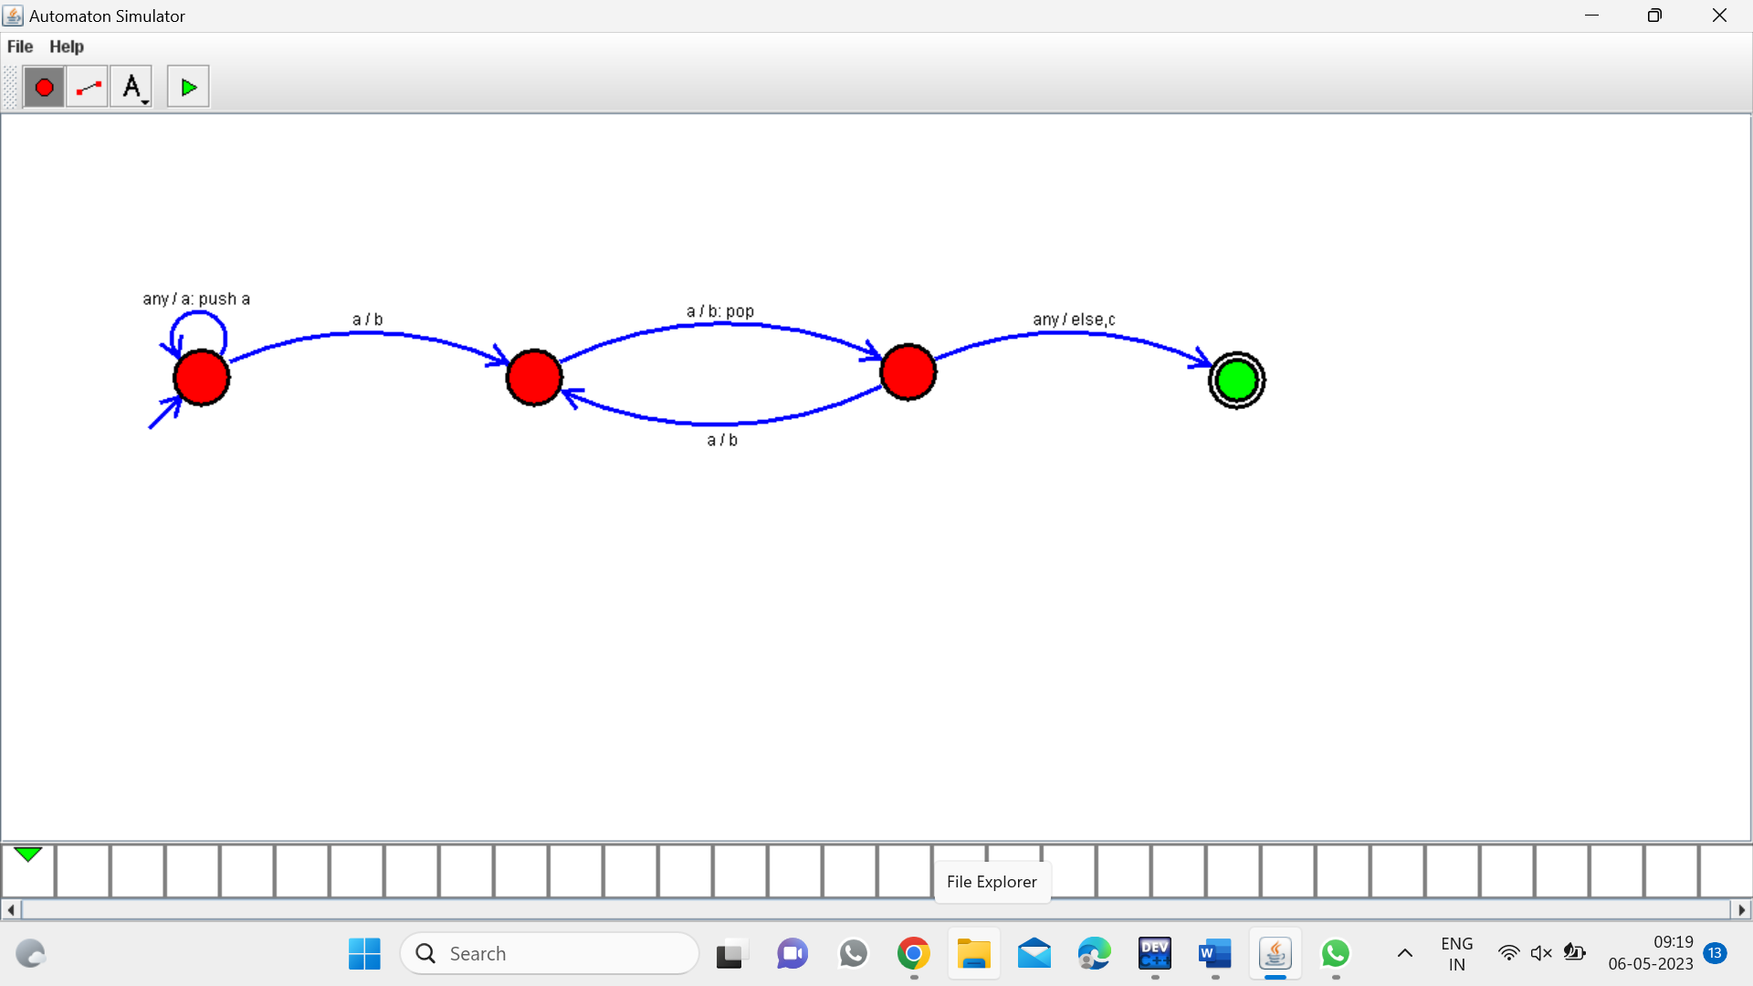

*Program17:*

*TM for palindrome*

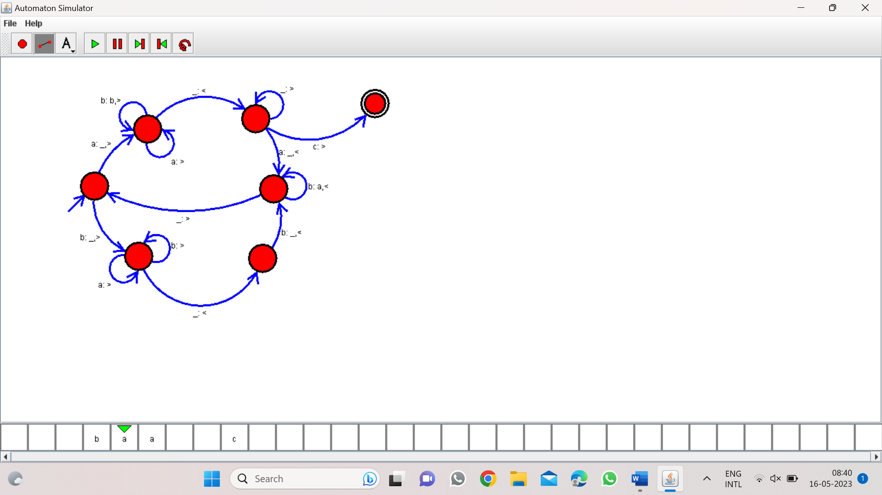

*Program 19:*

*TM for addition:*

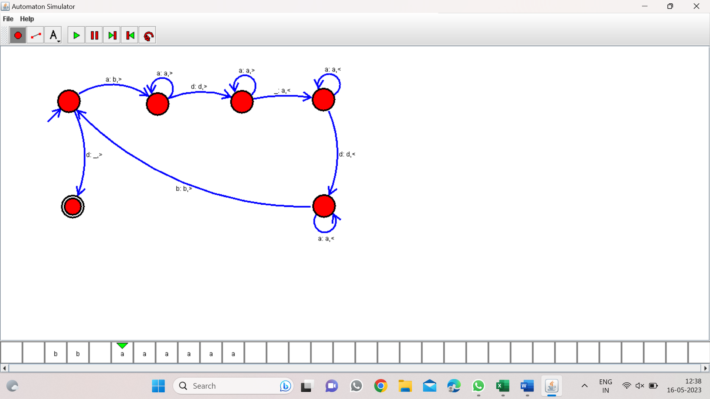

*Program 20:*

*TM for subtraction:*

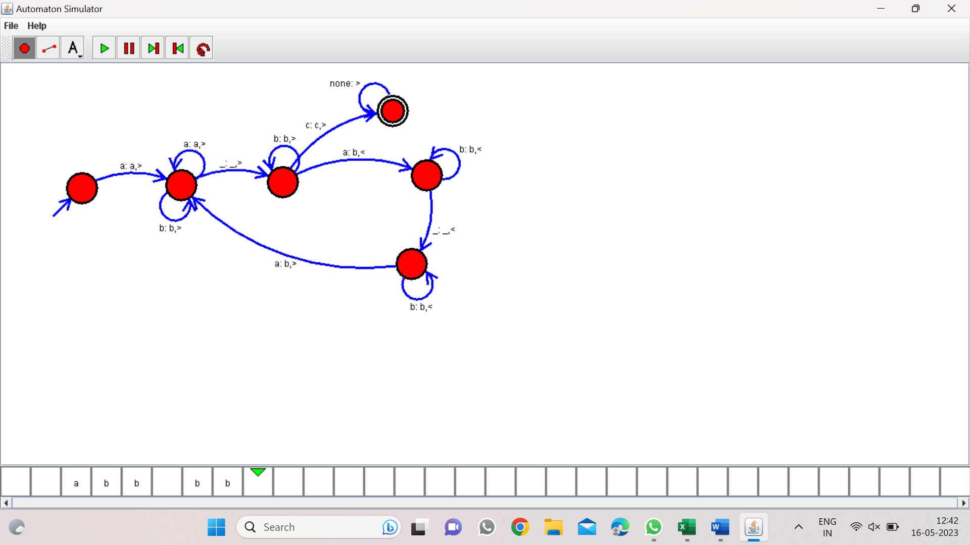

*Program 21:*

*DFA for even no.of a’s:*

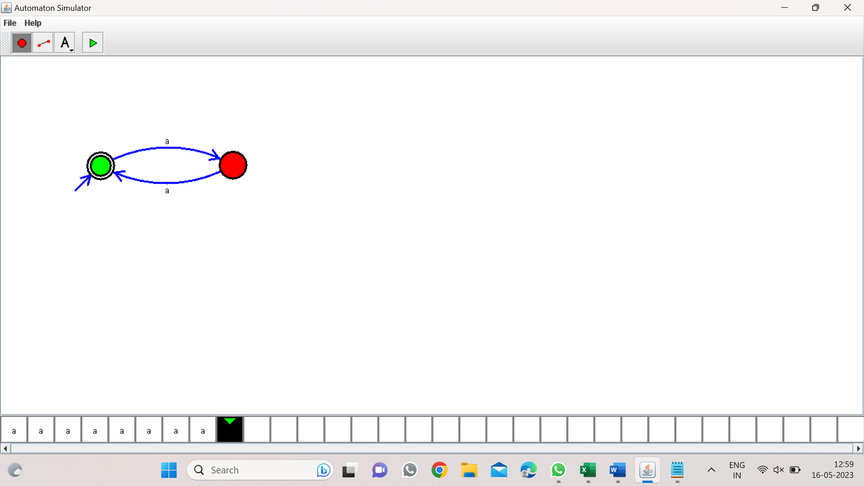

*Program22:*

*DFA for odd no.of a’s:*

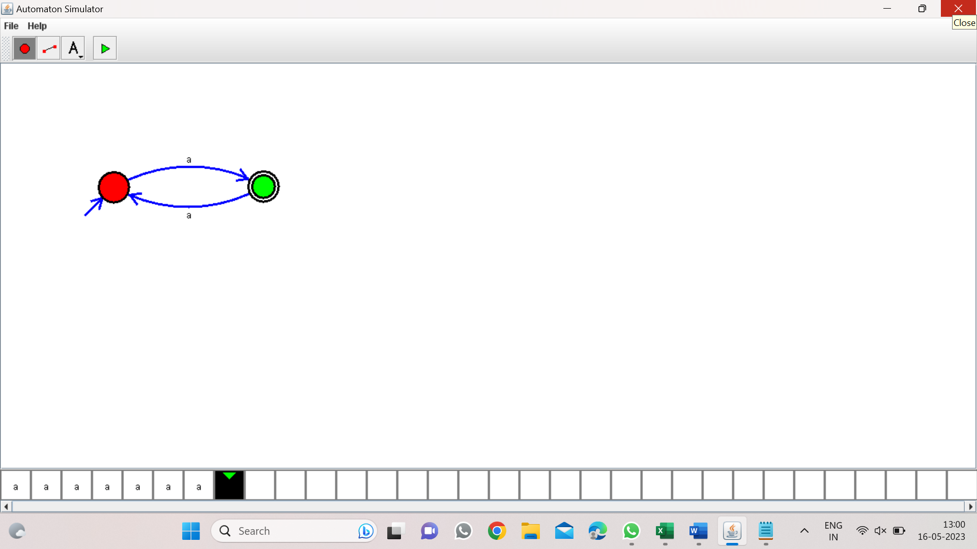

*Program 23:*

*DFA to accept string end with ab:*

*W=aaabab:*

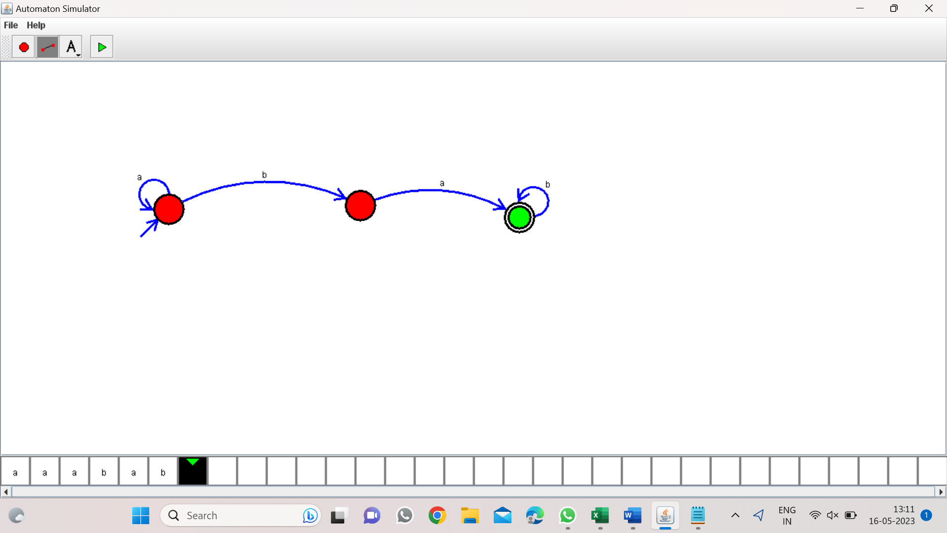

*Program 24:*

*DFA consisting substring ab:*

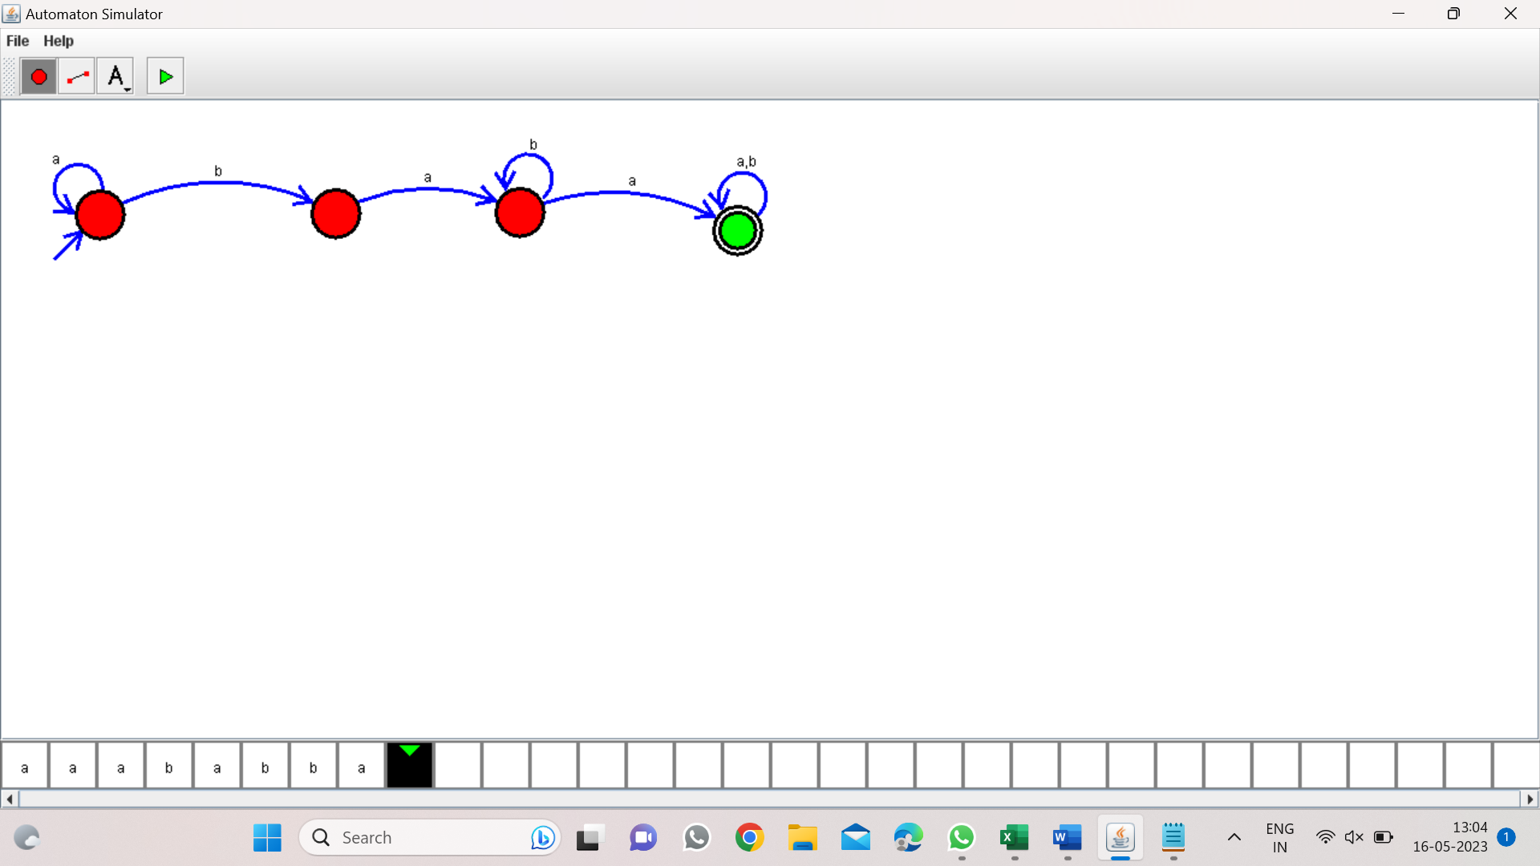

*Program 25:*

*DFA start with a or b:*

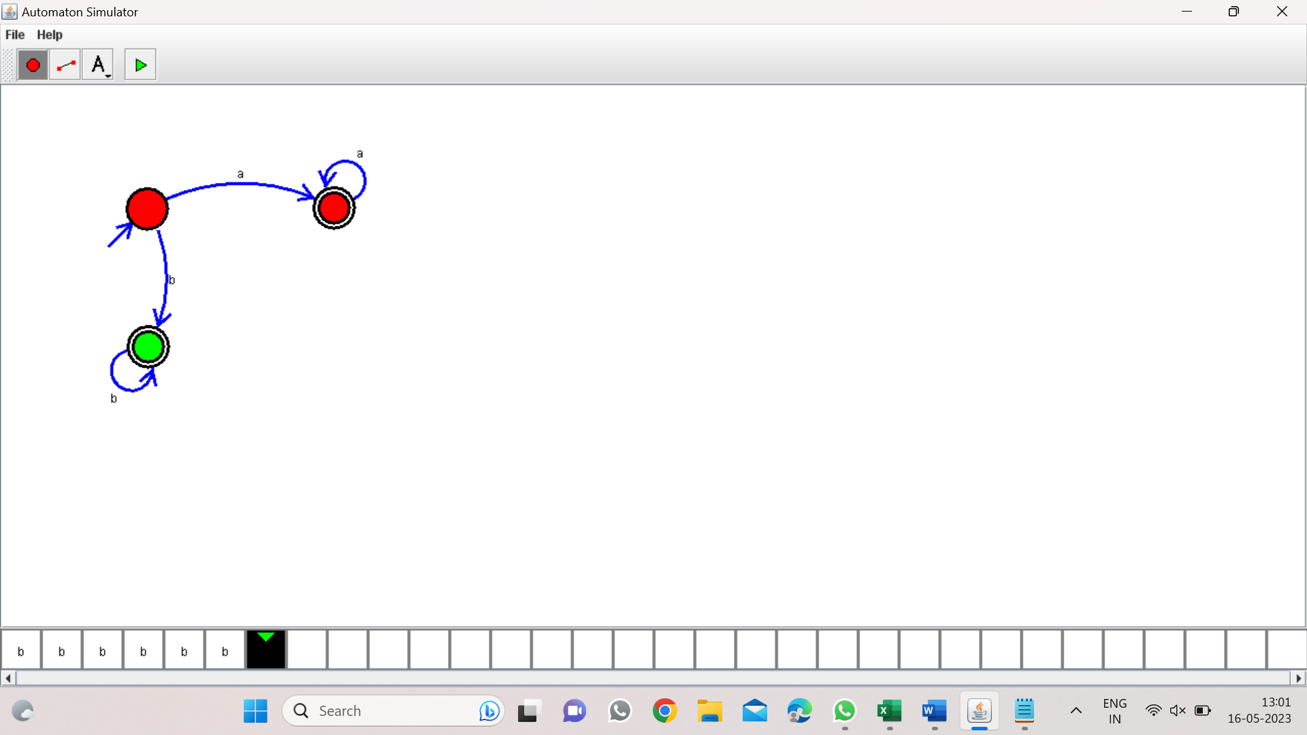

*PROGRAM 26:*

*TM TO ACCEPT STRINNG PALINDROME (bbabb):*

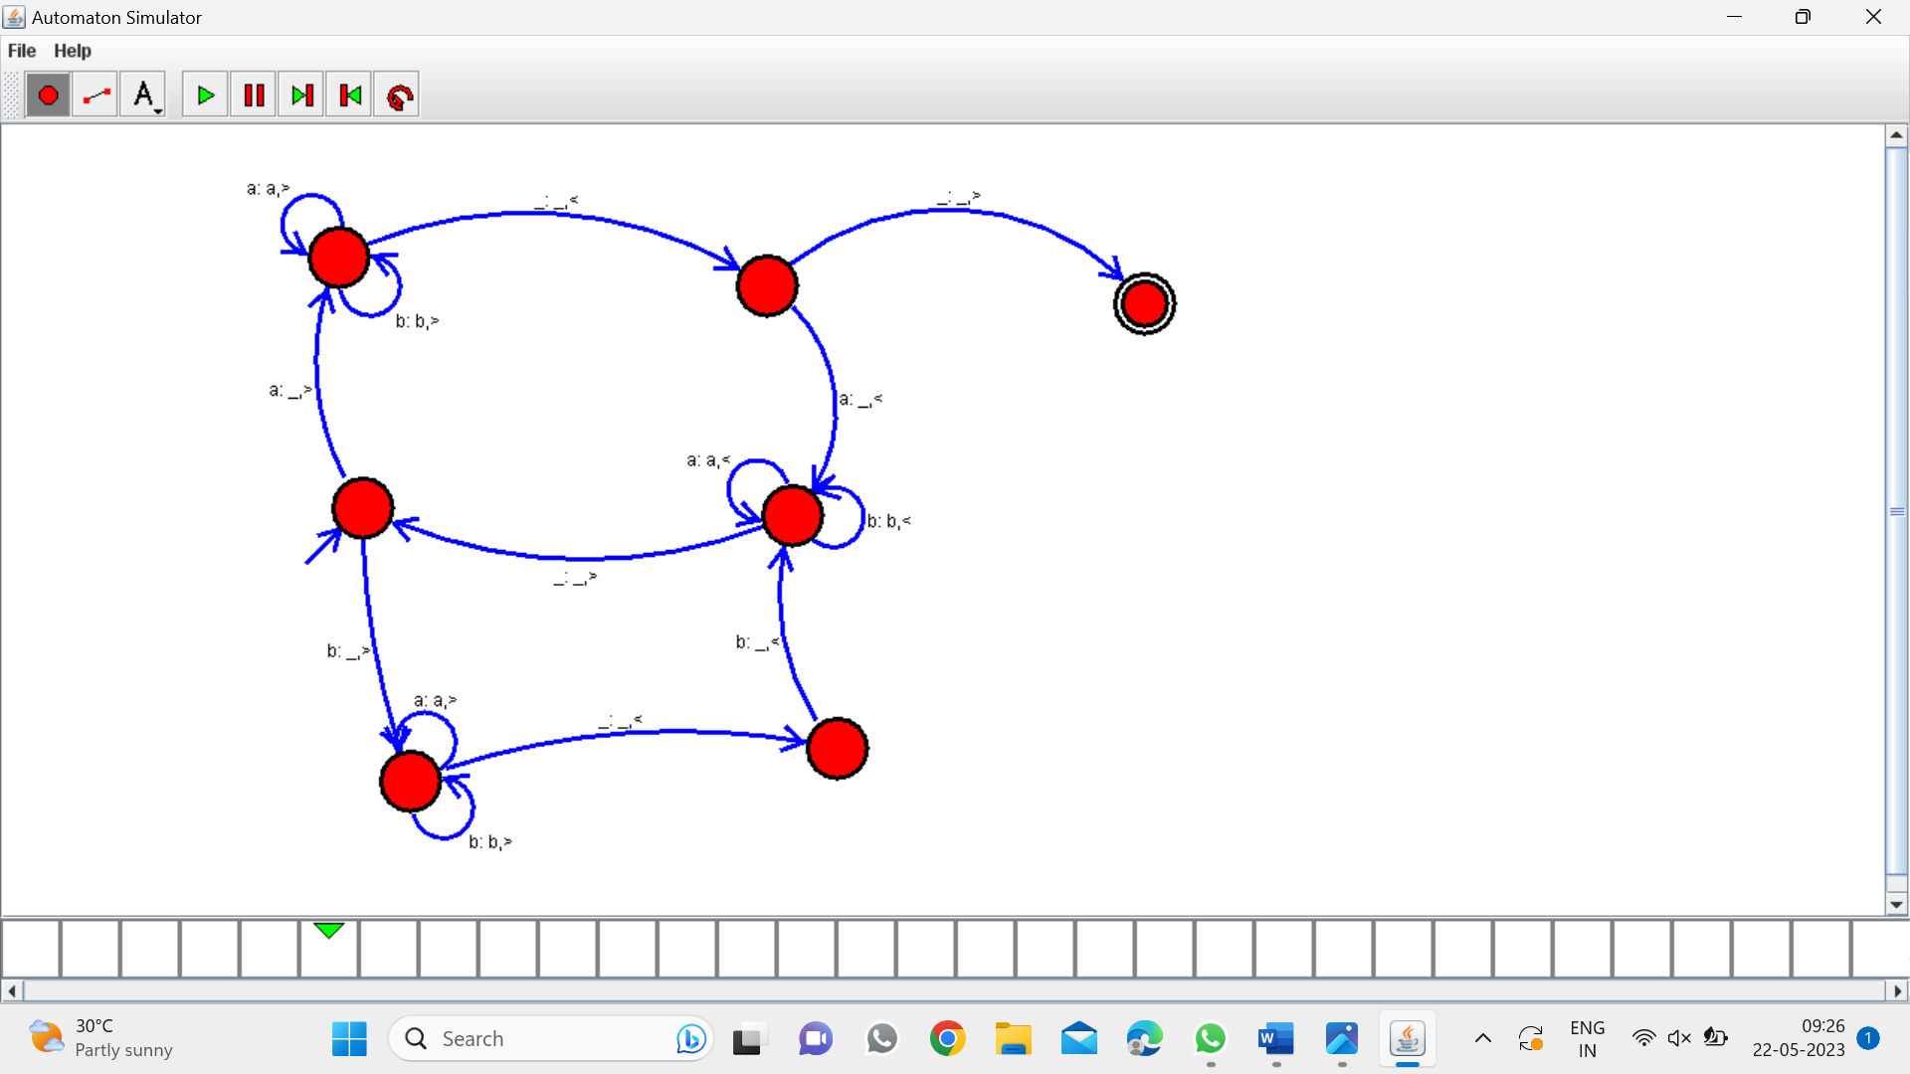

*PROGRAM 27:*

*TM TO ACCEPT wcw:*

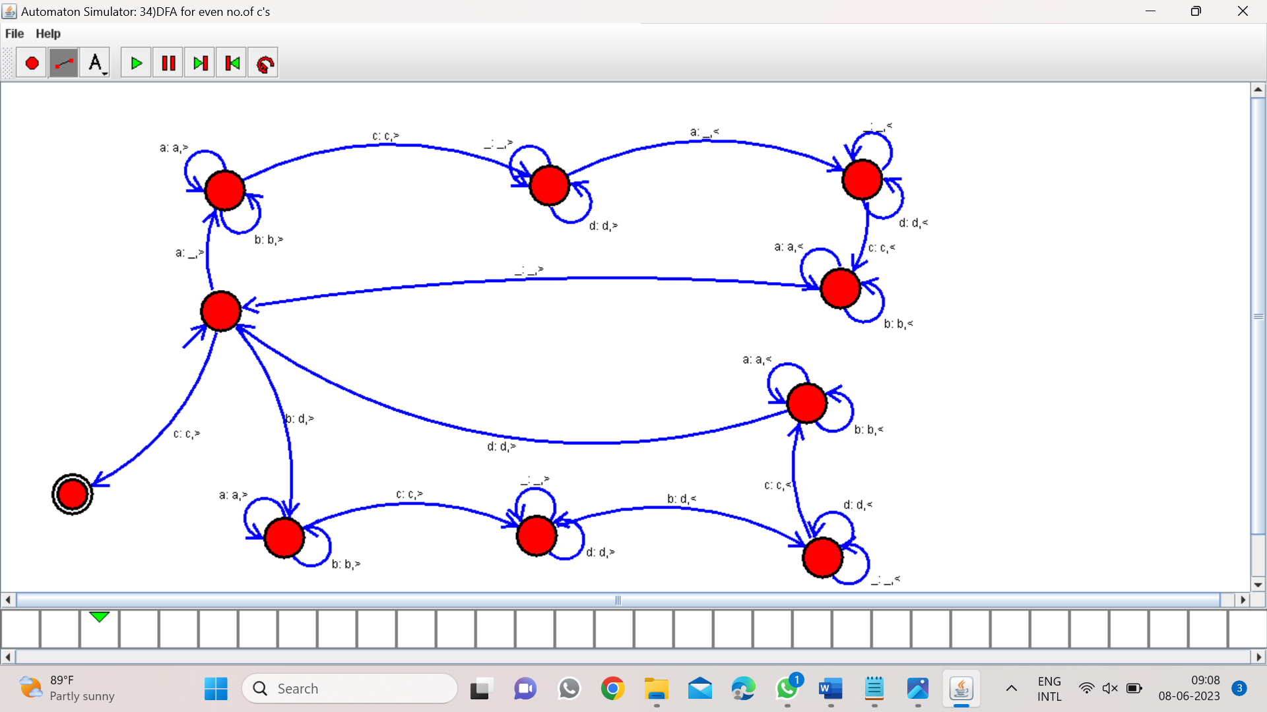

*Program 28:*

*DFA to accept the string abbaabab*

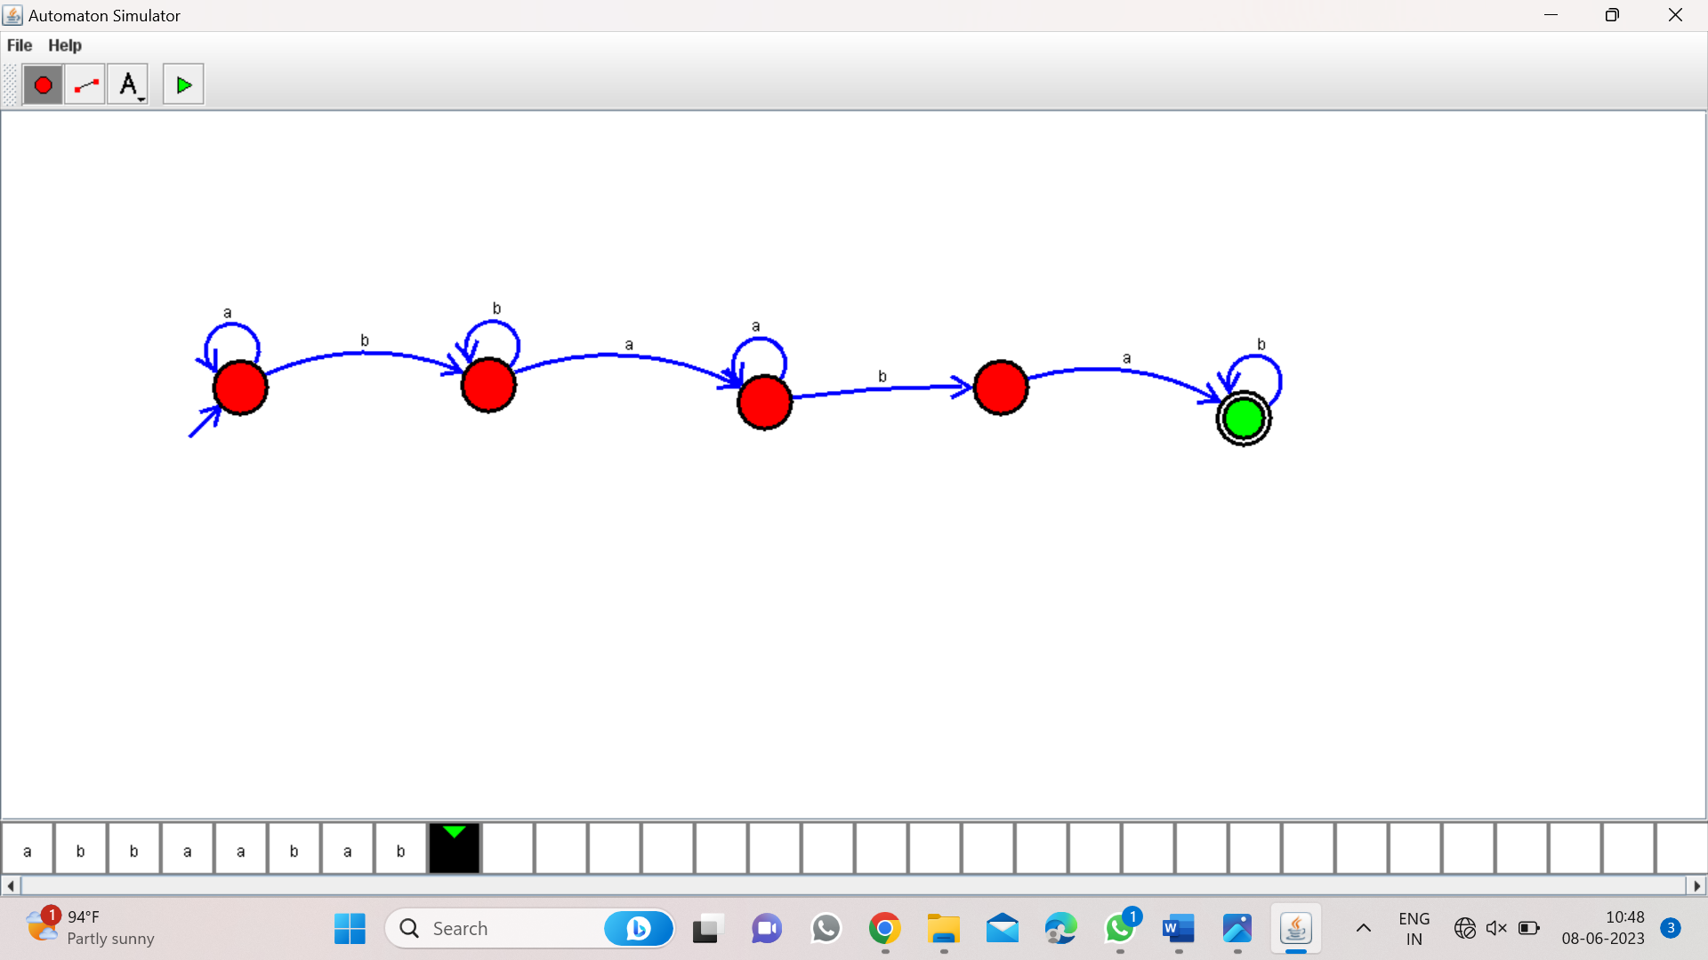

*PROGRAM 29:*

*DFA to accept bcaaaaa:*

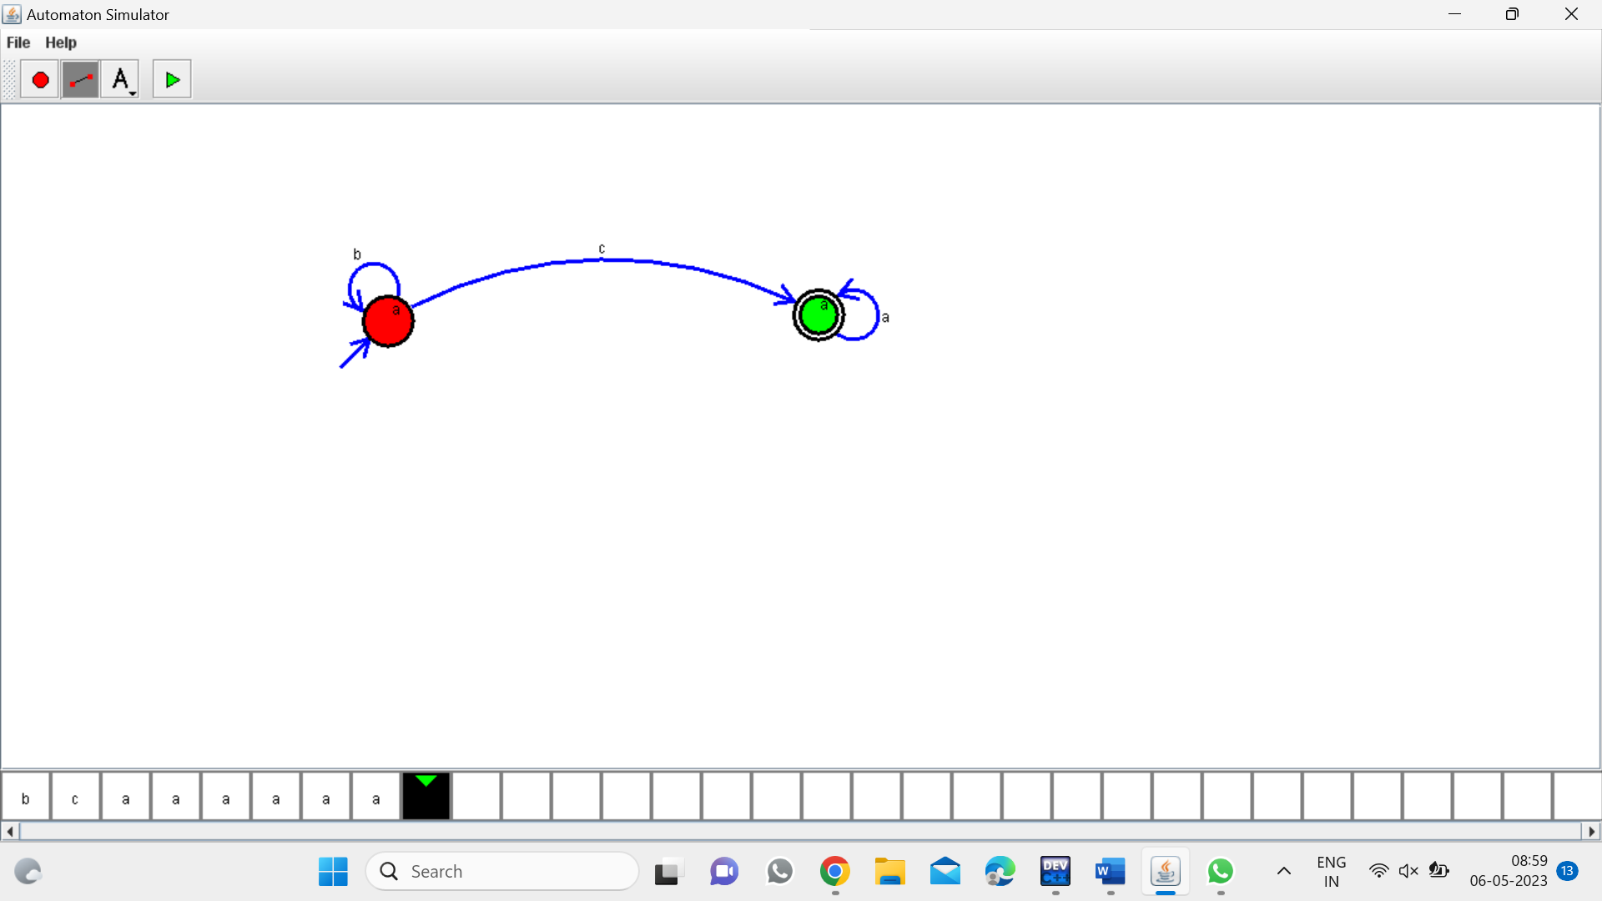

*PROGRAM 30:*

*NFA to accept aaaa:*

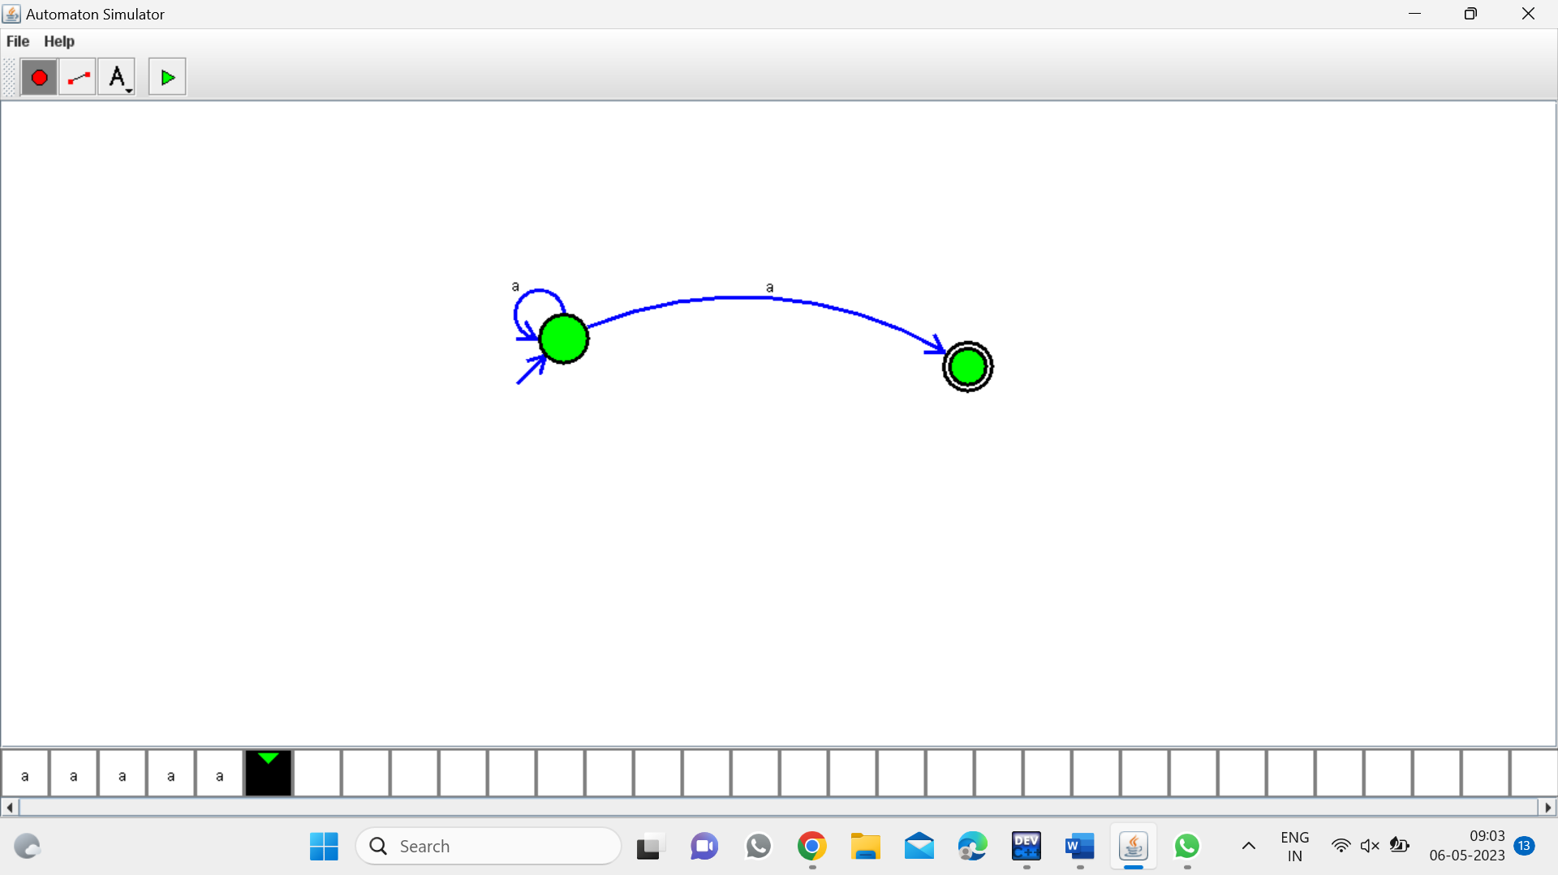

*PROGRAM 31:*

*PDA for a^nb^n:*

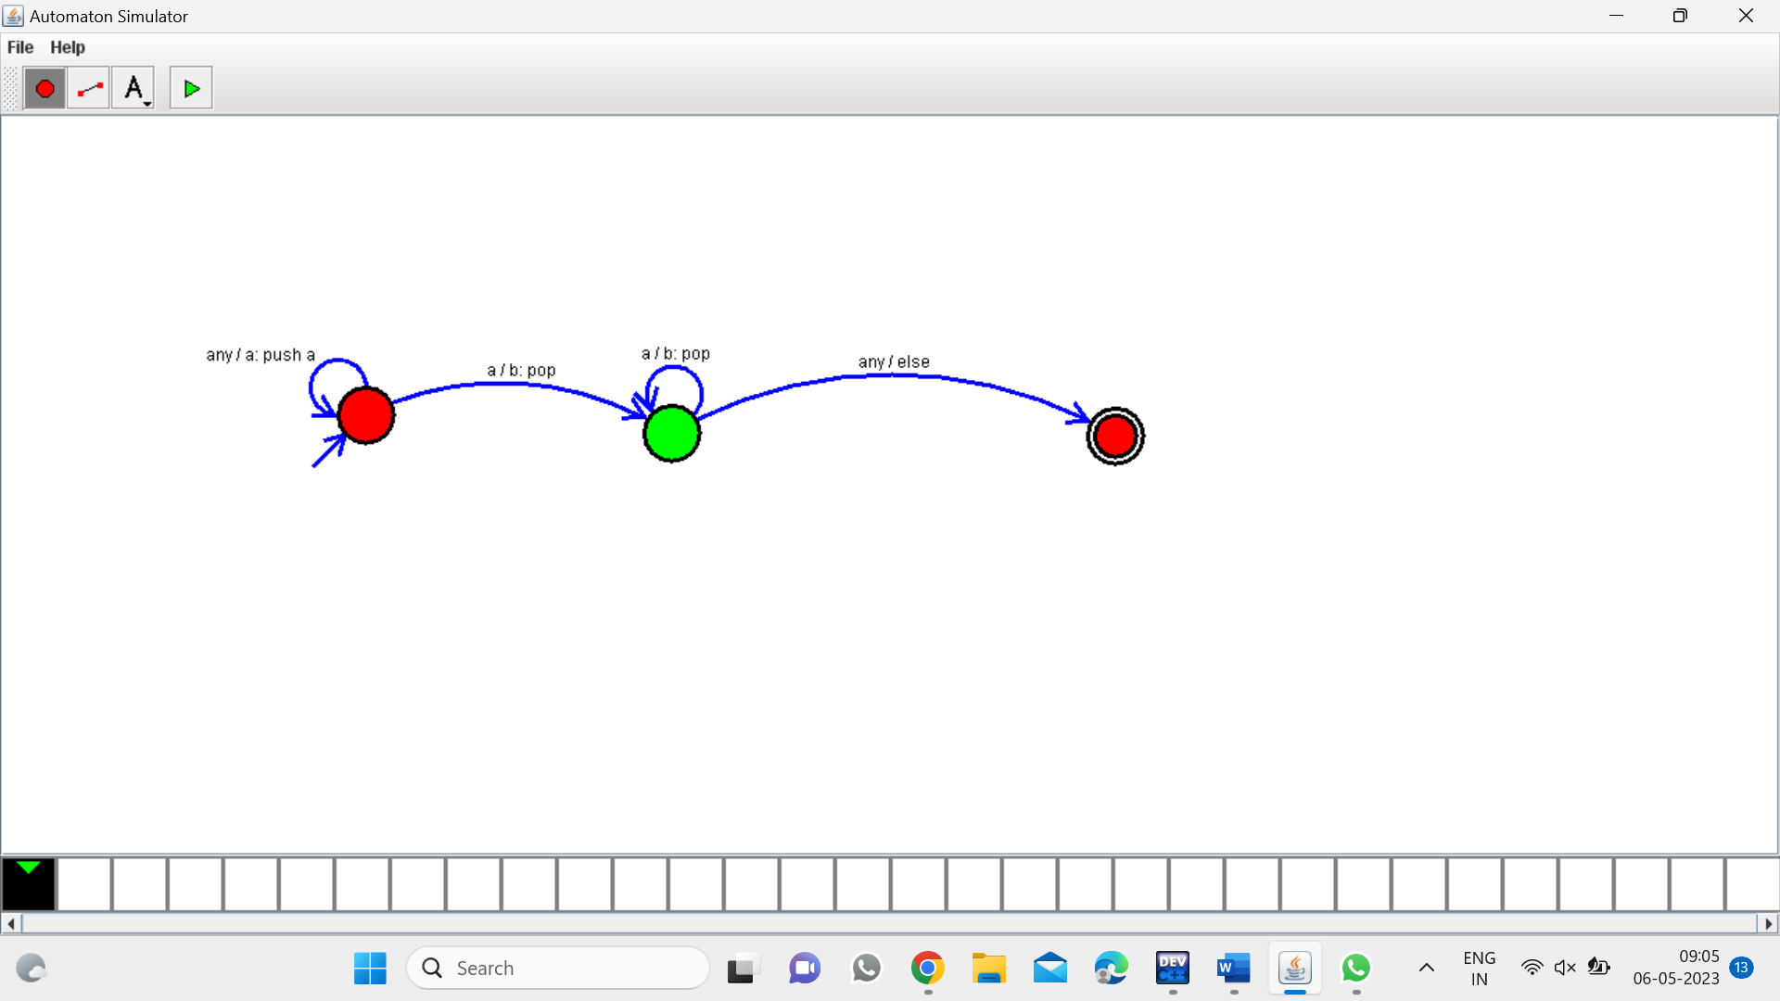

*Program 32:*

*TM for string coparision:*

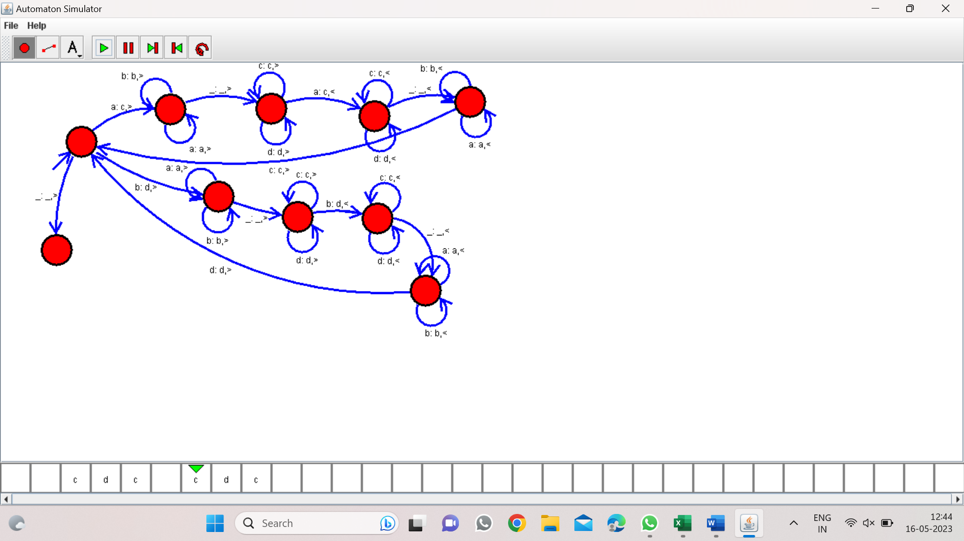

*Program 33:*

*DFA to accept string having abc substring*

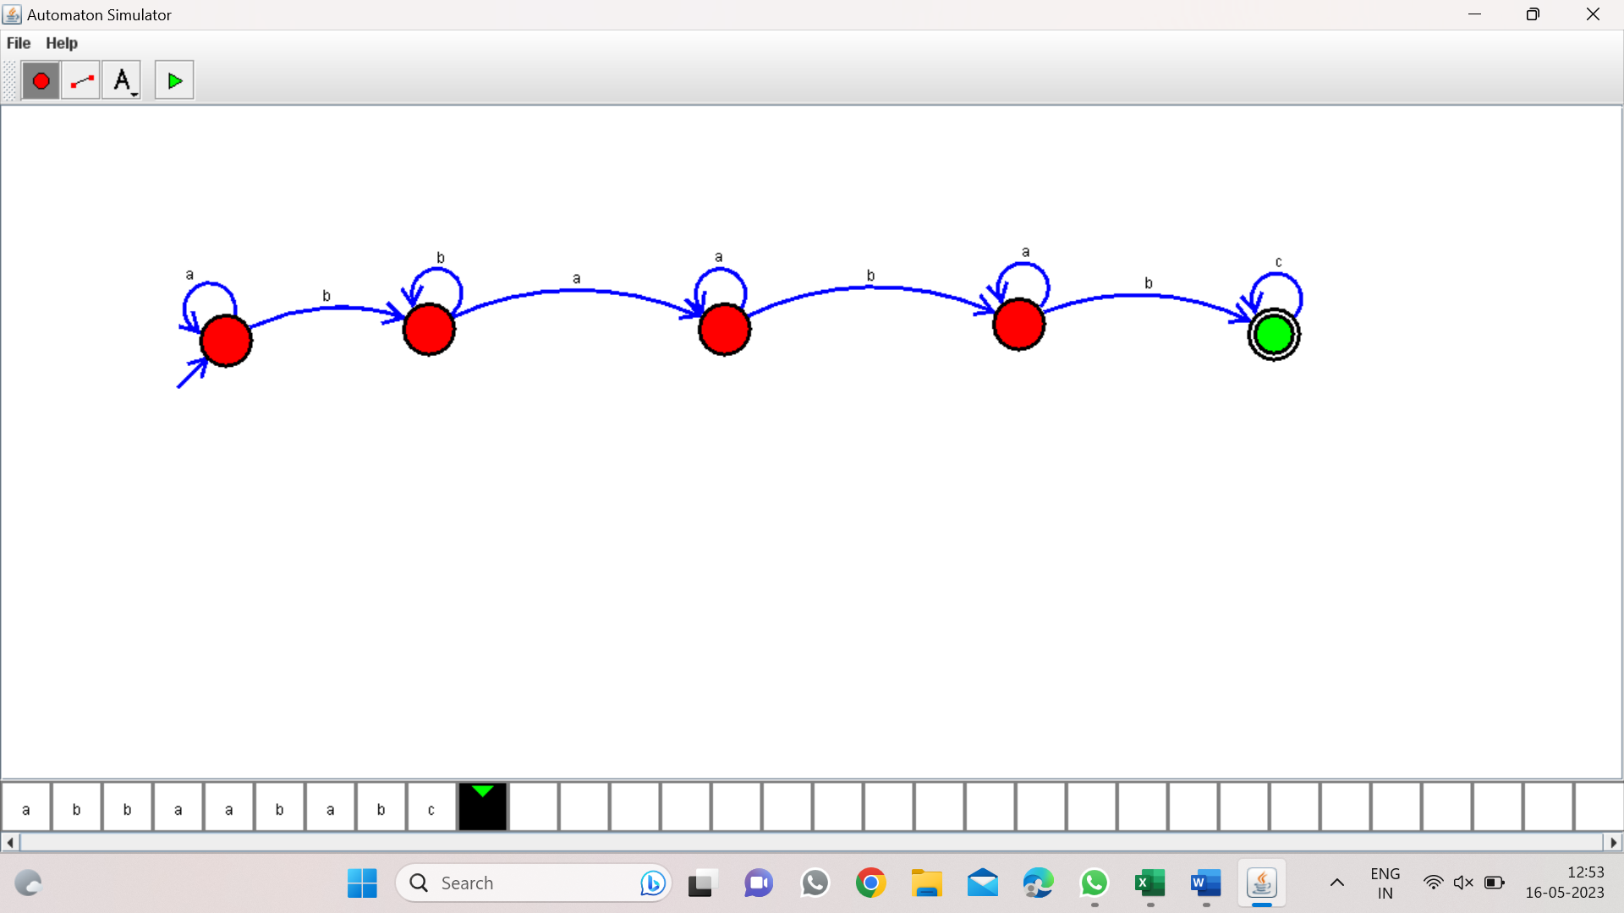

*PROGRAM 34:*

*DFA TO ACCEPT EVEN NUMBER OF C’s:*

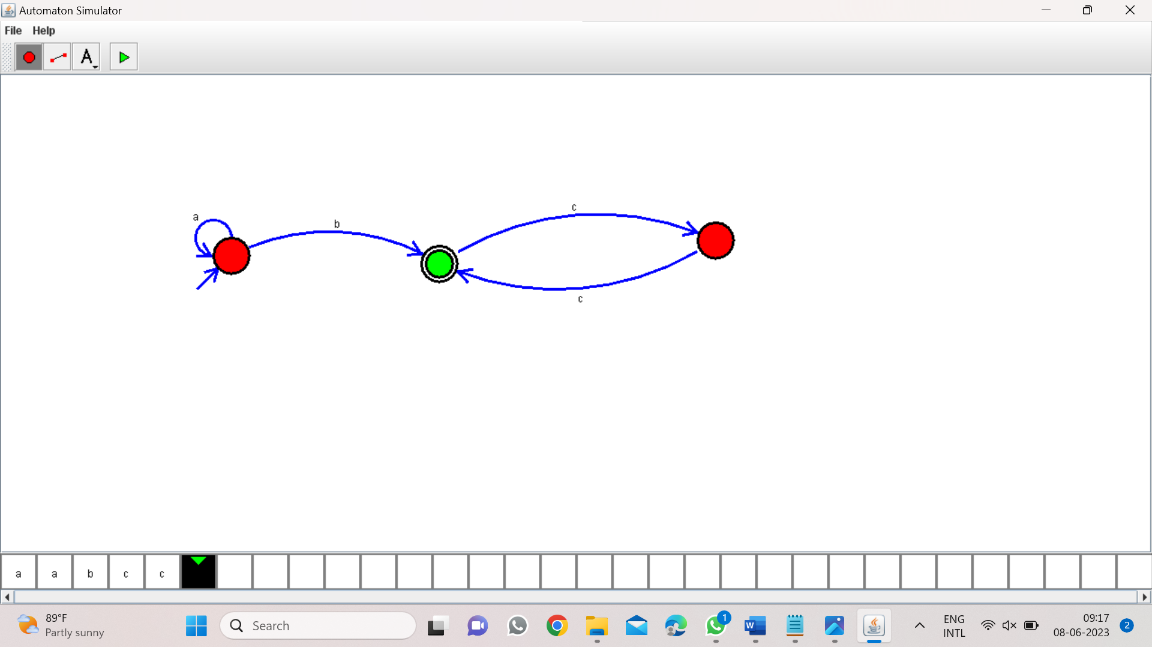

*Program 35:*

*DFA to accept a’s tripled over {a,b}*

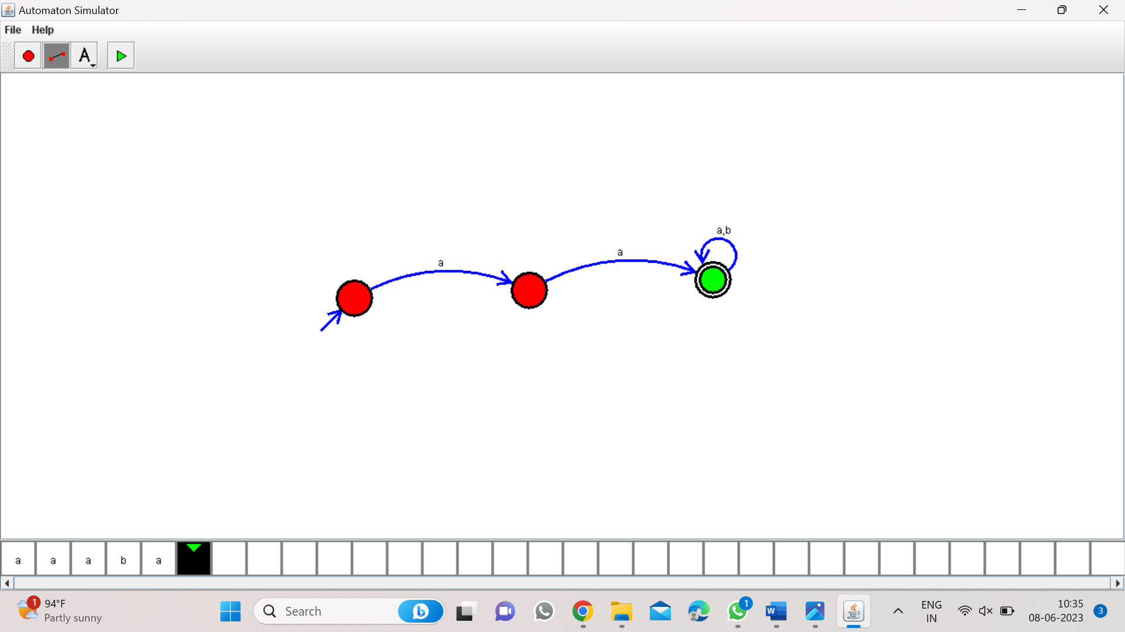

*Program 36:*

*NFA to accept start with a and end with b:*

*W=abaab*

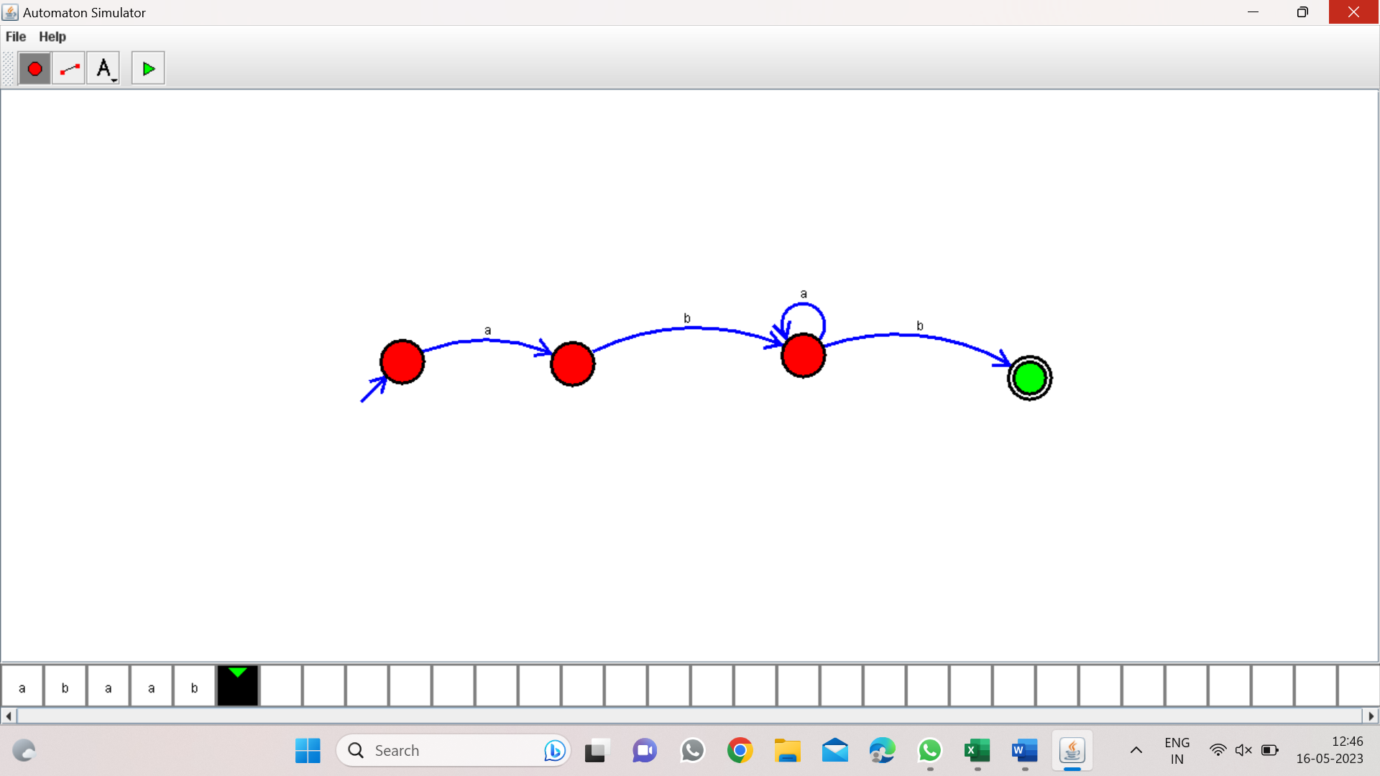

*Program 37:*

*NFA to accept string that start and end with different symbols:*

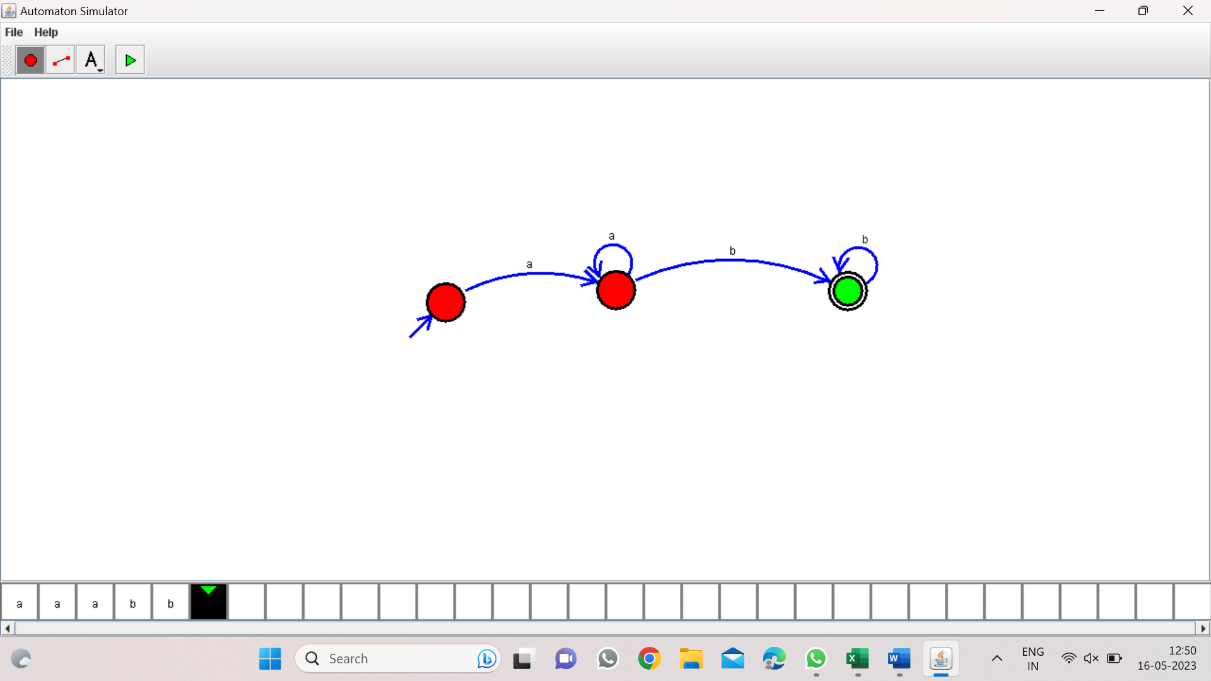

*Program 38:*

*NFA to accept the string bbc,c,bcaaa:*

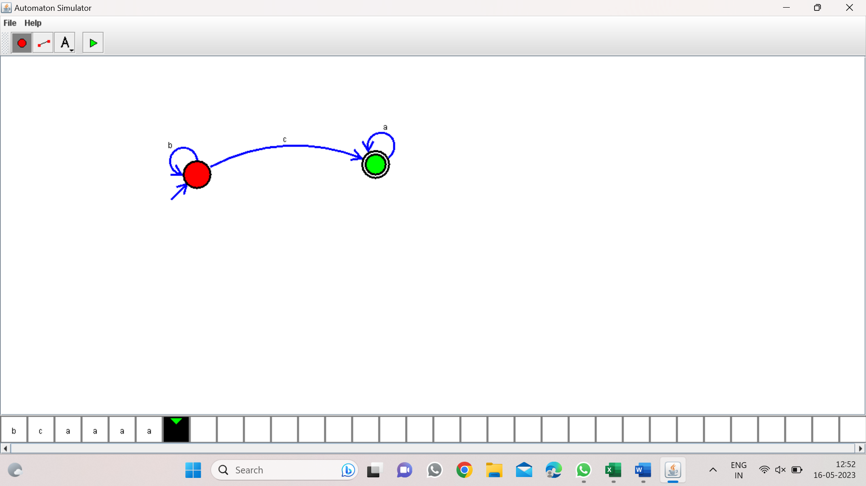

*Program 39:*

*DFA to accept the string that end with abc:*

*W=abbaababc*

**

*Program 40:*

*NFA to accept any number of b’s:*

